Boundary Section 3:
South Fleets to Old Hall Farm in Rylstone Village

Old Rylstone station and railway line from Swindon to Skipton
Chapel Lane
Fox House
Site of Old Hall - now Old Hall Farm
Morainic mound in Coonlands Hill
Mucky Lane

Highlights:
- This boundary section traverses pasture-land South of Fleets House, crosses both the railway from Swindon Quarry and the road from Hetton to Cracoe and then passes across more farm-land to the main B265 road and then down Chapel Lane to Old Hall Farm, Rylstone.

- Morainic mound within Coonlands Hill field with medieval rigs and furrows over it.

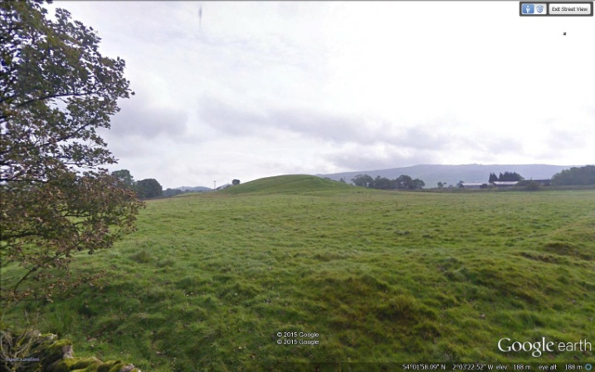
- Railway crossing and site of old Rylstone station, shown below, which opened in 1903 and closed to passengers in 1930 and to freight in 1969. It was reopened in recent decades to transport limestone aggregate from Swindon quarry to Skipton and beyond, and occasionally now has a steam train running through it.

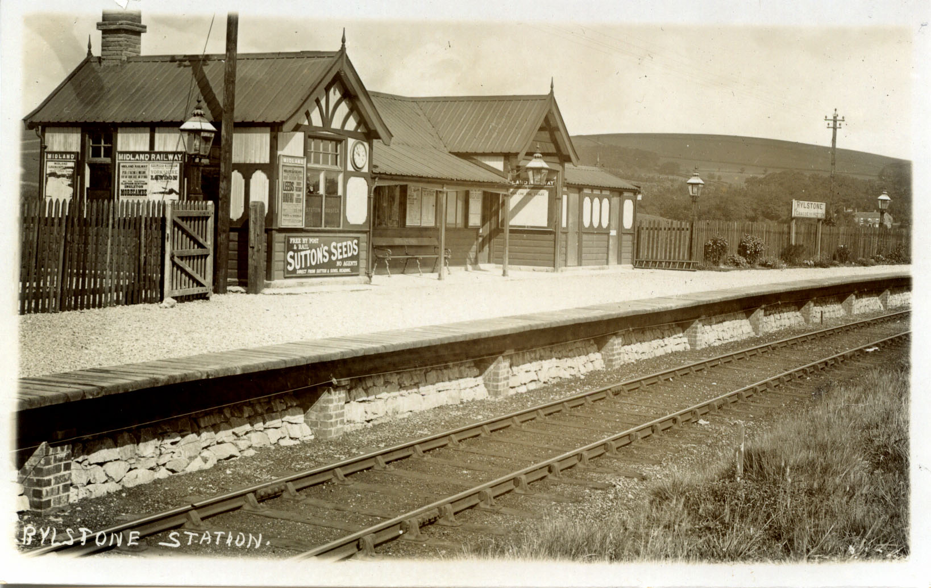

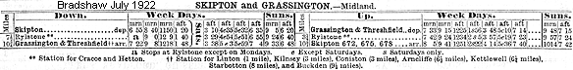

- Mucky Lane is an ancient hollow-way leading from Rylstone village to North Moor, Boss Moor and Cracoe and passes through a medieval field system. Today it is used as a local walking route and bridleway.

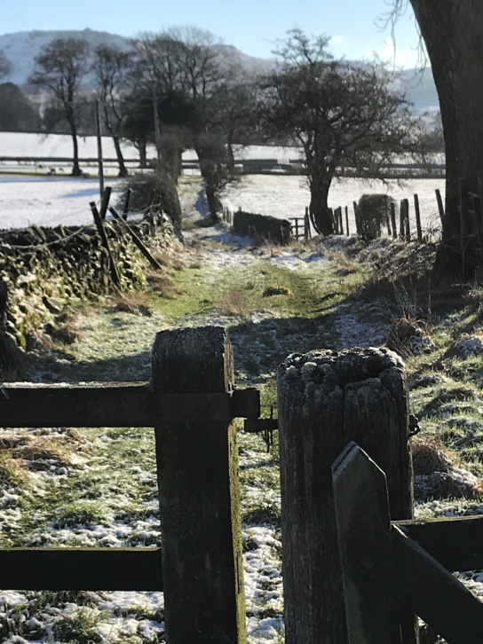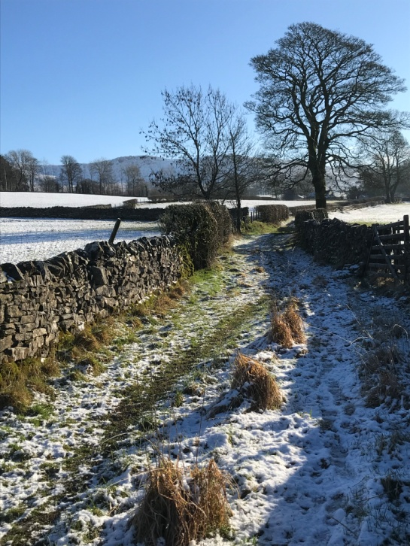
Two views along Mucky Lane in the direction of Rylstone.

- Chapel Lane is part of an old track-way leading up the Dales via Cracoe from Rylstone where it links in to the old Skipton-Rylstone road. It was also the route for Cracoe people attending St. Peter's Church. At the point where the Rylstone-Cracoe boundary crosses the lane is to be found an old stone trough, which is often said to be the base of an old Quaker cross. Local legend has it that during the 1665 plague, from which Rylstone people suffered, but Cracoe folks did not, vinegar was placed in its hollow and Cracoe people placed food underneath the stone in exchange for money left in the vinegar by their Rylstone neighbours. Hence the old local name for this artefact is 'the vinegar stone'. (Parish Magazine, 1978).

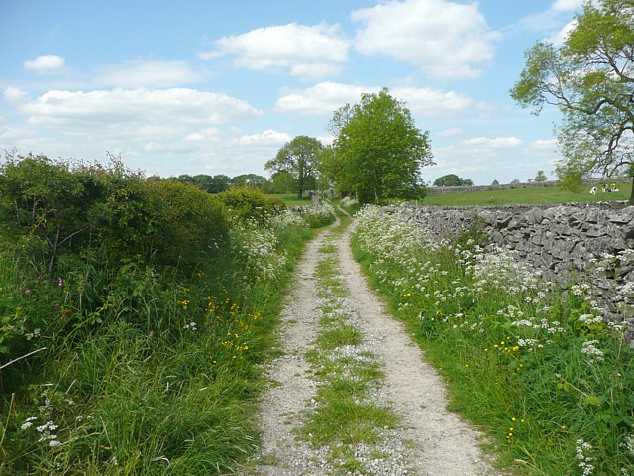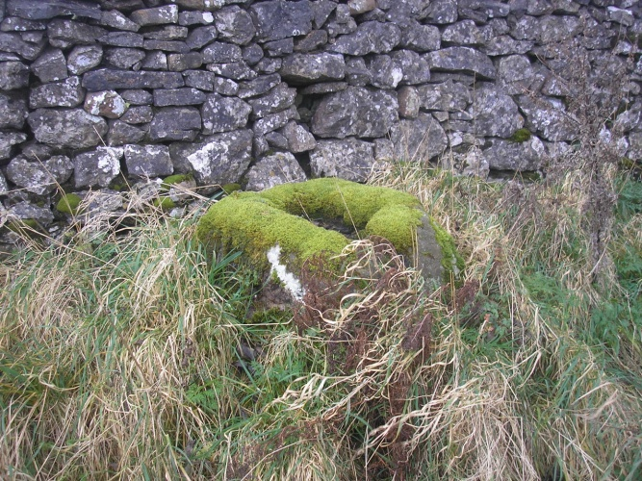
Photo of part of Chapel Lane. The 'Vinegar Stone' on Chapel Lane
(Photograph taken by Humphrey Bolton
and freely available from geograph.org.uk)

- Fox House is the site of an old Quaker meetings house and burial ground. A historical note on a planning application to Yorkshire Dales National Park Authority, dated 18 July 2018, describes the history of the building and site as follows:

'The site is of considerable historic significance being the earliest Quaker burial ground for the North of England Society of Friends. The site was later used as the Rilston Friends Meeting House, including for the Friends annual national meeting in 1652 and 1653. The name of the house derives from the founder of the Quaker movement, George Fox. In 1792 the Rilston Meeting was closed, and in 1813 the meeting house and burial ground were sold for £96. About 1864 a village school was being kept in the building. From about 1880 onwards the building was used as a barn and shippon. The building was little altered from 1880 until the time of conversion to a dwelling, which was around 1981'.
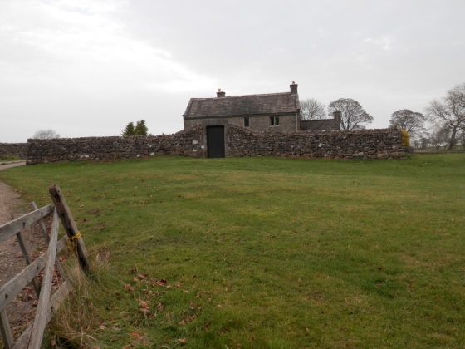
Fox House - photo taken from Raikes Road in 2013.

