Boundary Section 5:
Old Hall Demesne to Yethersgill, Embsay

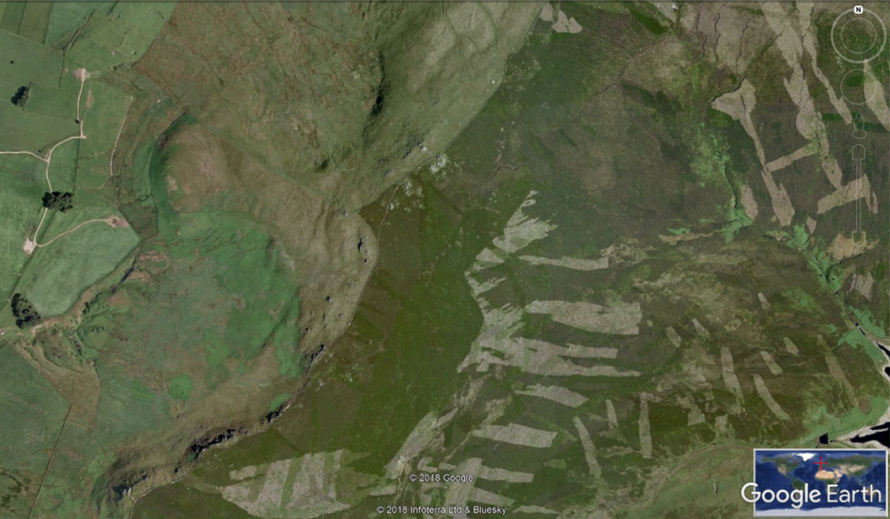
Cracoe
Cairn
Old Hall
Demesne and Hall Fell
Path along Rylstone Fell Edge
Rylstone Cross
Upper Barden Reservoir
Yethersgill

Highlights
- This section of the boundary first rises from the steep boulder-strewn slopes of the Old Hall Demesne, onto Rylstone and Barden Moor, as the two photographs looking up to the Fell Edge from Rylstone pastures and the view under the Fell Edge of the heavy gritstone walls and rocks show.

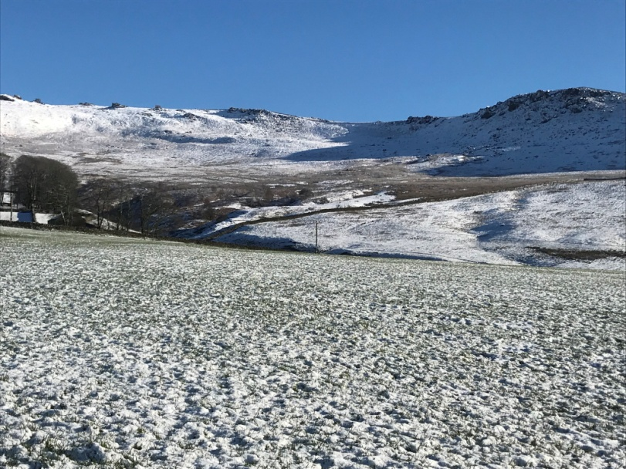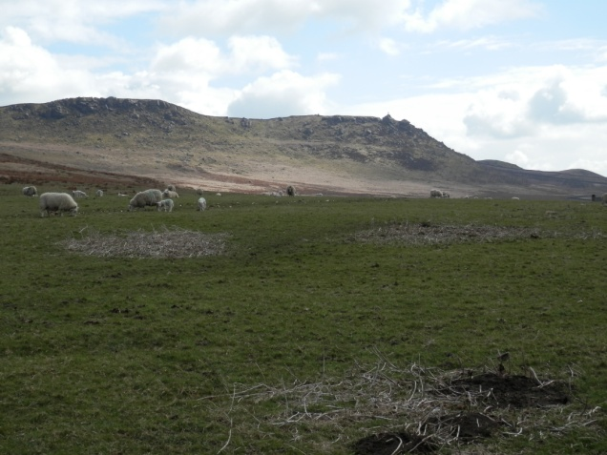

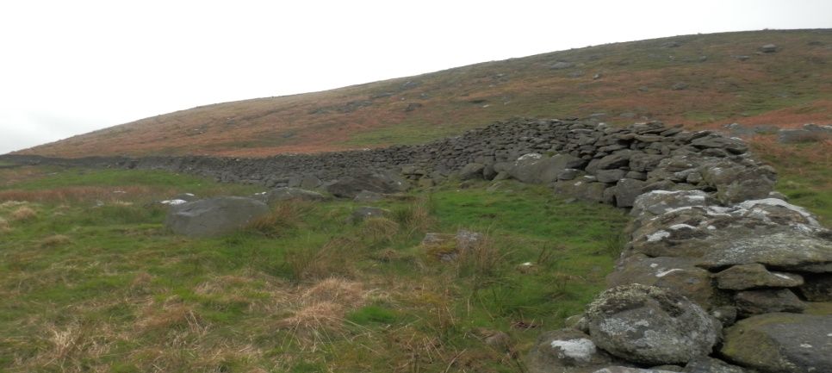

- The boundary then passes close to Cracoe Cairn - a First World War memorial obelisk. The yellow line in the Google Earth screenshot above marks the path along the Fell Edge from Cracoe Cairn to Rylstone Cross. This 'Edge' is formed by massif millstone grit rocks and is a popular walking route.

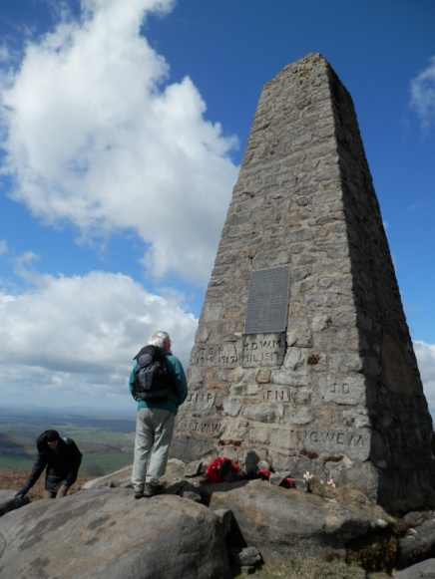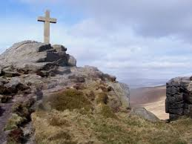
Cracoe Cairn Rylstone Cross

- Below is an unusual photograph taken in the snow from close to Rylstone Cross to Cracoe Cairn, which is at a higher elevation.

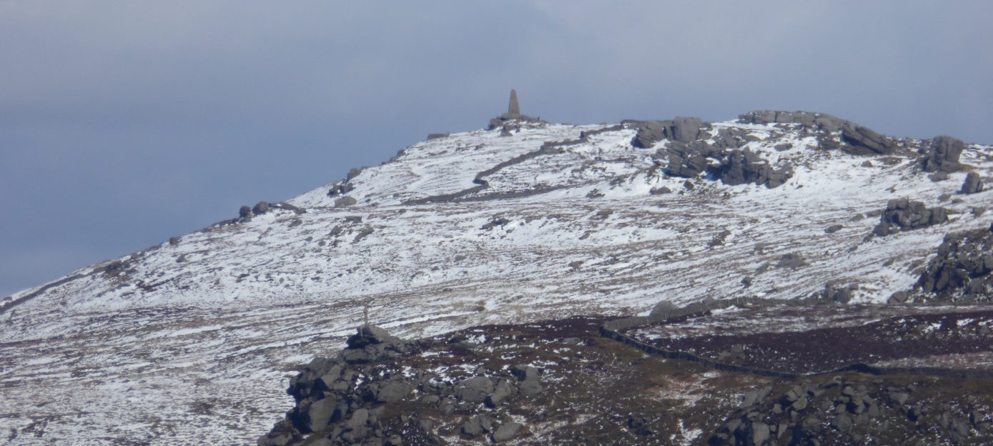

- The stripes in the Google Earth screen-shot at the start of this section, and visible in the photograph below which is taken on Hall Fell, are made by periodic burning of strips of heathland in order to regenerate the heather on Barden Moor. This moorland is owned by the Devonshire Estate and is used for game shooting and sheep farming.

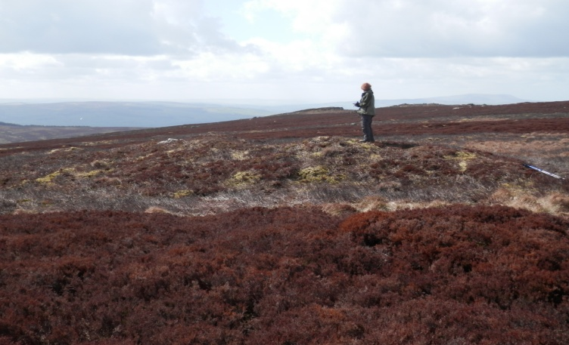

- There are magnificent views down to Rylstone, Hetton and across to Malham Dale, and beyond, from this Edge, as the photograph shows.

,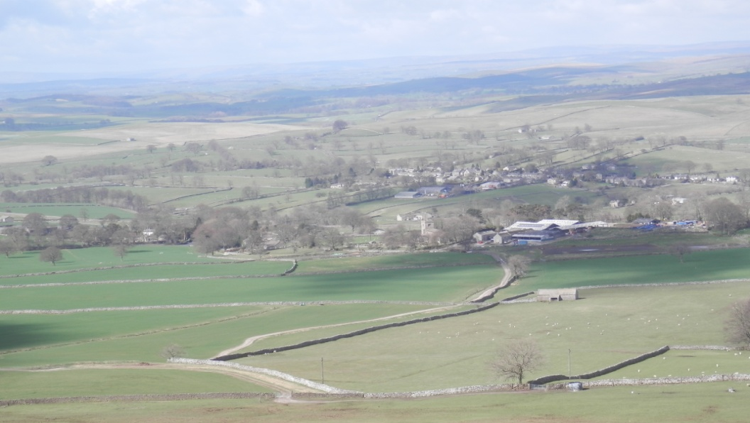

- The millstone grit which composes Rylstone Fell and underlies Barden Moor has long provided local people with stone for building, for walls and for such items as troughs and mill stones. The slopes under the Fell Edge are pock marked by small quarries.

- In Raistrick's 'Discovering a Village' chapter in his book, 'Old Yorkshire Dales' about the development of Rylstone, he notes that, 'In two places on Rilston Fell a finished and partly finished millstone are still lying, partly embedded in the soil', and there are other examples of part worked boulders to be found under the Fell. Photographs and descriptions of these are found in Helen Ward's diaries. Helen was a friend and helper of Dr. Raistrick and the 'Louise' mentioned is Louise Standevan who lived at Scale House.
