Boundary Section 7

Waterfall Gill to Sandy Beck Bar
Norton Tower Hill
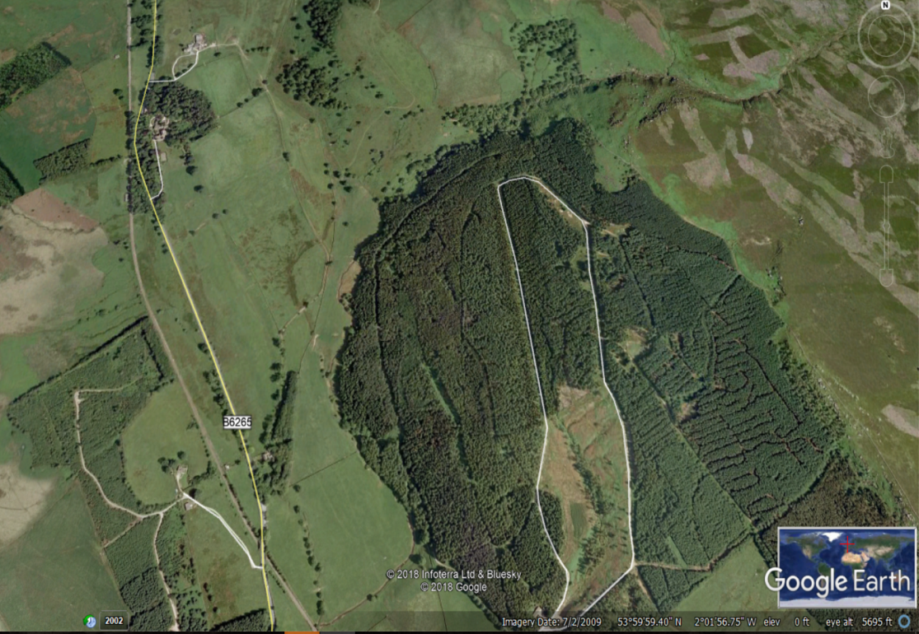
Waterfall Gill
Old road from Rylstone to Skipton
Scale House
Toll House at Sandy Beck Bar

Highlights
- This boundary section is one of contrasts. The South Eastern boundary of Rylstone with Embsay parish begins in high, open moorland on Barden Moor, descends along Waterfall Gill, skirts the slopes of Nettlehole Wood and finally ends on the B6265 - Skipton to Grassington Road - at Sandy Beck bar in low-lying pastureland.

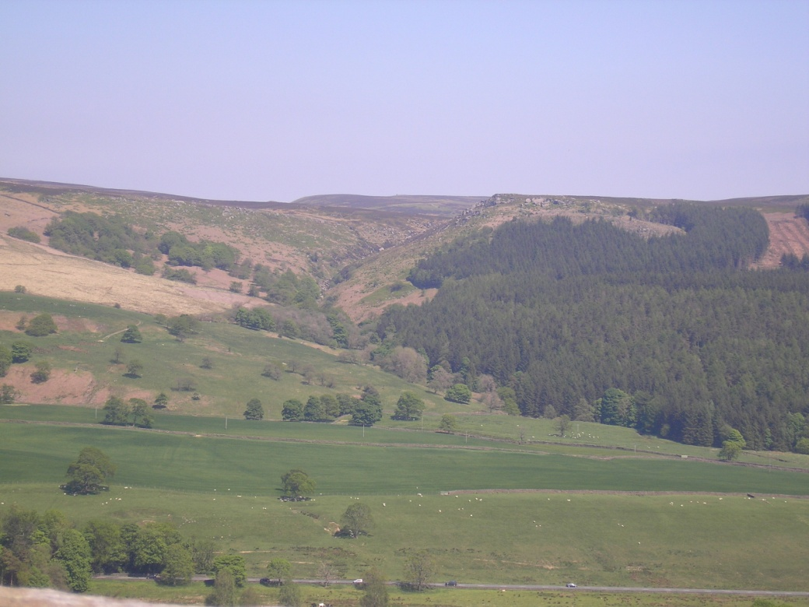
View up Waterfall Gill and the Rylstone boundary with Nettlehole Wood on the right.
- Waterfall Gill here also marks the old boundary between the Nortons of Rylstone's and Cliffords of Skipton Castle's lands. These were sworn enemies and often in dispute over land and deer rights.

- Both were said to have built look-out towers either side of Waterfall Gill, although only the ruins of the Norton Tower survive. This is sited on a spur of open moorland, as the photos below depict, and it looks down on the Old Hall and church. Much of the tower is composed of deep-coursed stonework which is roughly dressed from squared rubble boulders of gritstone.

The Tower is now under the care of English Heritage which has recently undertaken some restoration work on the old Tower walls. There is some dispute about the purpose of the Tower, said to have been built by Richard Norton in about 1540. Was it really, or only, a watch tower or was it a summertime lodge for the Nortons, where they could shoot game, engage in archery or other leisure pursuits?

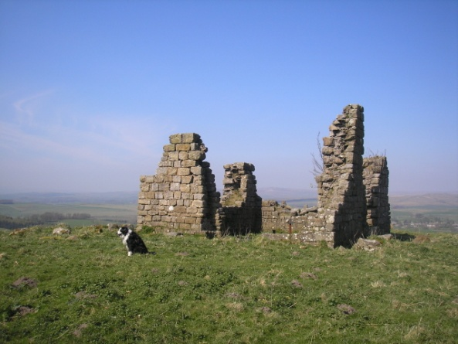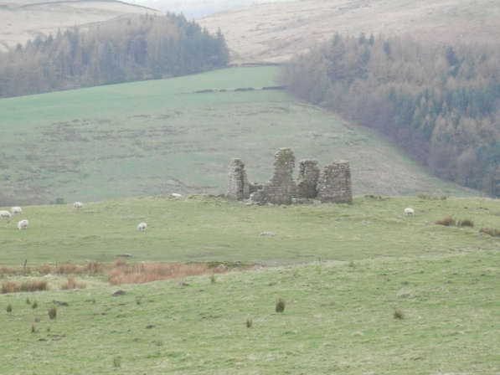

Here is a project description of Norton Hill and what can be seen here:

'The track up to Norton Tower site is modern. Near the top of the slope it cuts through older features near the Tower. There seems to be possible double bank and ditch features there. The listing for the tower says it stands amidst extensive earthworks and is only part of an important archaeological site which includes prehistoric field clearance cairns and medieval rabbit warren pillow mounds.

It is clear that there are other long earthwork walls with double orthostats that run at odd angles to the tower and are of a different date. They appear earlier and perhaps prehistoric. Some walls run down into the wood. This style of walling may be medieval or prehistoric. Apart from these are cairns of clearance cobble. These remain prominent even where parts of the hill field have recently been improved. With clearance cairns present, the earthwork walls are likely to be field boundaries'.

- After descending to the valley floor from Norton Tower Hill, and passing through a pasture, Rylstone's South Eastern boundary reaches a junction with both the old and new Rylstone to Skipton roads. The old road - now only a green track-way - is shown in yellow on the Google Earth screenshot at the start of this section.

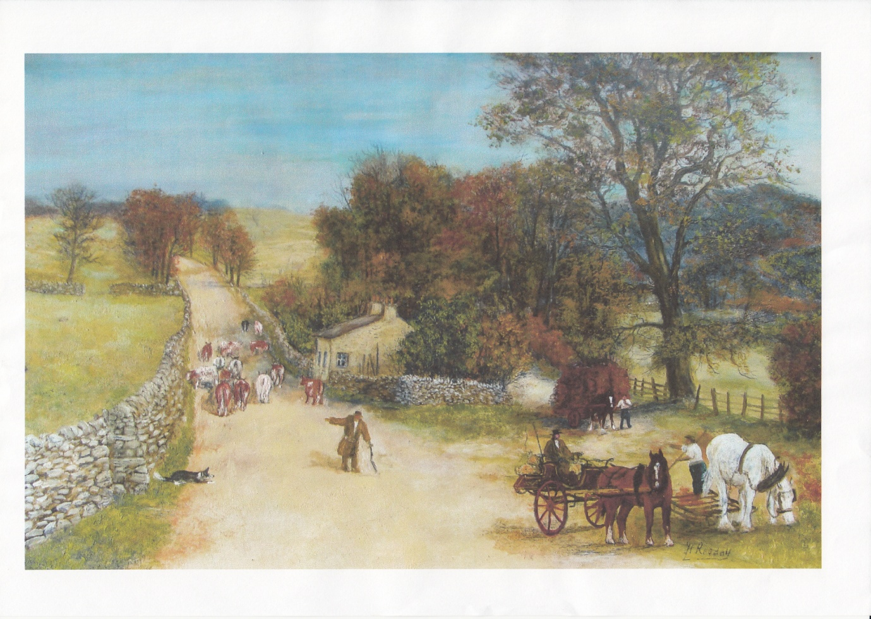
Looking up the old road with old toll house from Sandy Beck Bar.
Painting by Harry Ready by courtesy of Kathleen Carlisle.

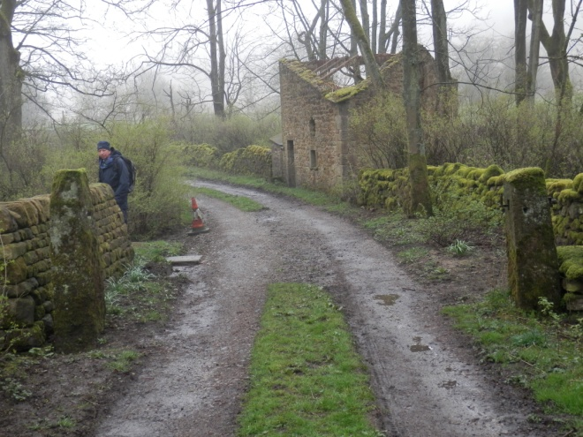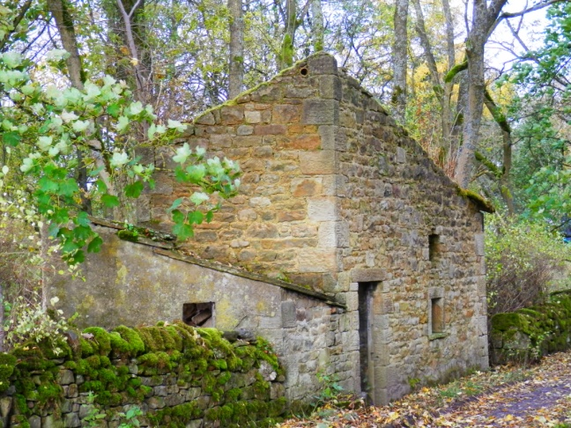
The start of the old road today More details of the old toll house

- The new road - the Skipton to Cracoe Turnpike - was built in 1853, with a new Toll House at Sandy Beck Bar. The Griffiths family lived at the toll house for many years - long after it ceased to be used for tolls - and worked for the Standevans at Scale House. The toll house has been unoccupied since about 1950. The two photographs below show how it looked in the 1940s and today.

