Boundary Section 10:

From Hetton Mill, along Hetton Beck, to Skirse Gill Bridge

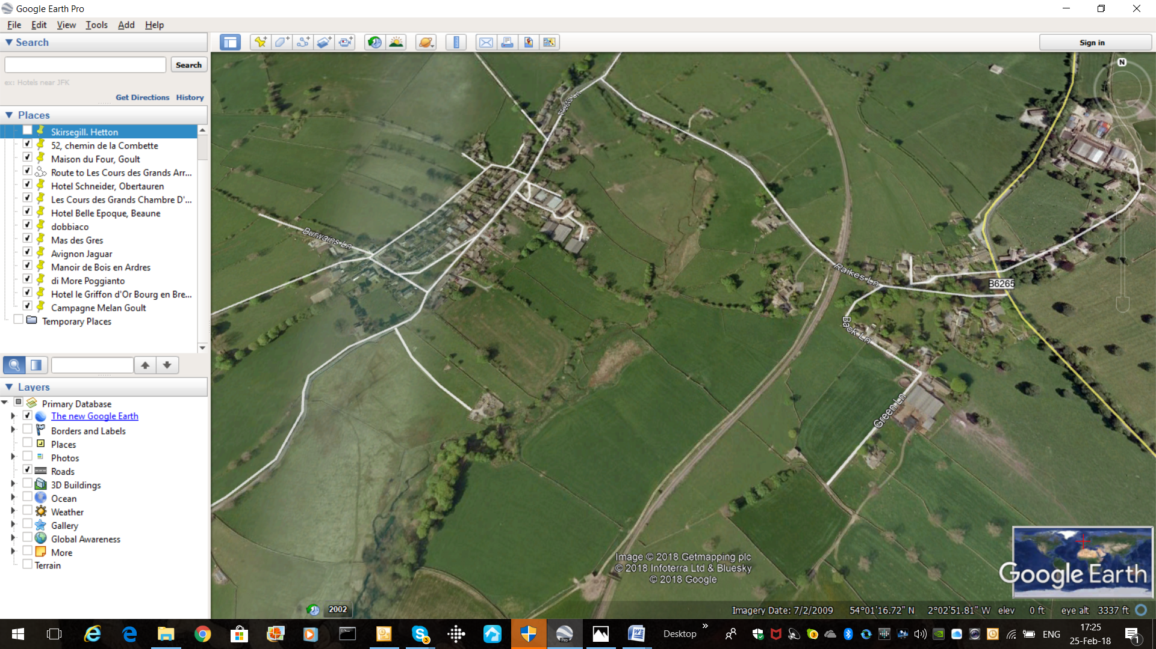
Skirse Gill bridge
Kirk Bridge on Strait Lane
Site of old 'Rilston' and Hetton mill

Highlights

- This boundary section between Rylstone and Hetton parishes follows Hetton Beck, which meanders through pastures and meadows from its junction with Calton Gill Beck up to Skirse Gill Bridge. It is liable to flooding for all of this section and there was an infamous flood in the 1970s, as graphically shown in the photo of Hetton Beck at Skirse Gill Bridge.

- Strait Lane (also known as Fairy Lane by locals) is a deep narrow lane, of medieval origin or earlier, leading from Hetton to Rylstone, and was the route taken by Hetton parishioners to St. Peter's Church. Orthostat walls, probably of medieval date, line the hollow-way. The hedge-banks are of hazel and the uncommon field maple, a small tree often surviving in medieval lanes.
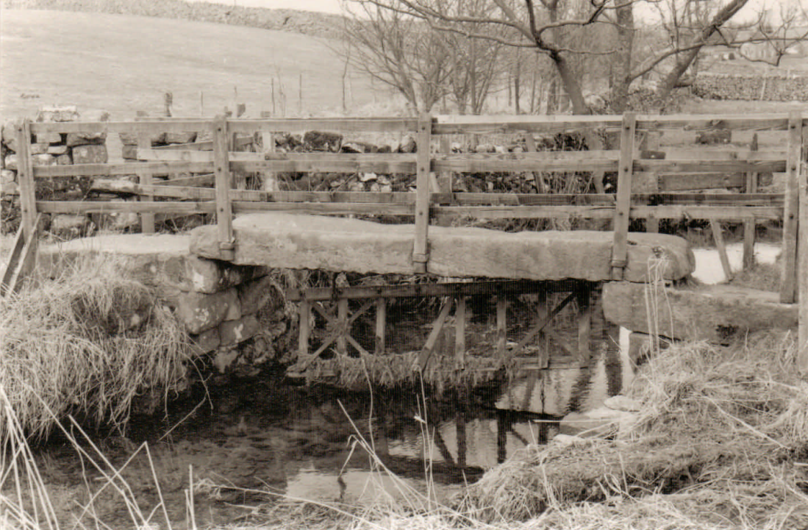
- Kirk Bridge, shown above, is an old packhorse bridge, over Hetton Beck on Strait Lane on the boundary between Rylstone and Hetton parishes.

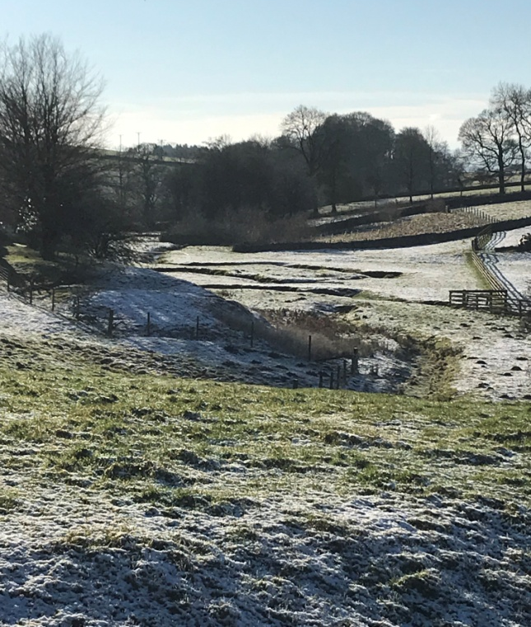
View looking down Hetton Beck towards Kirk Bridge

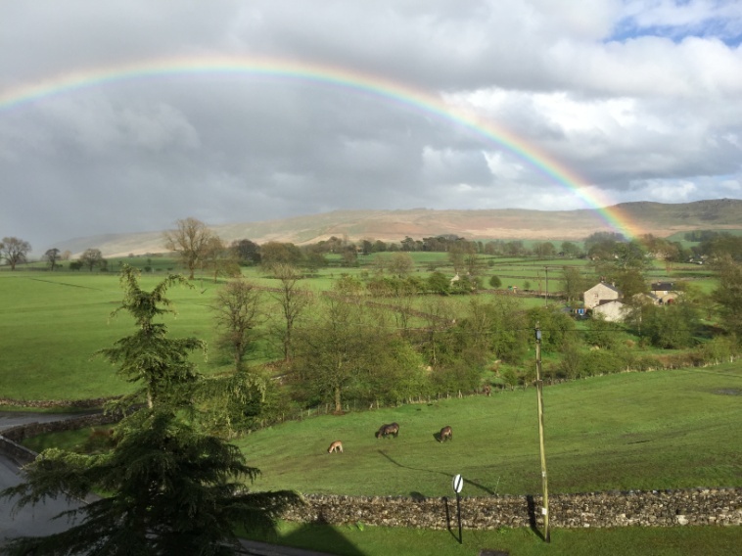
Fox House, once a Quakers' burial ground and meeting house
Hetton Beck - boundary between Rylstone and Hetton
Old track-way; now a linear banking
Skirse Gill Bridge
View from Hetton over Hetton Beck into Rylstone parish and the Fell beyond.

