Boundary Sections 11:
Skirse Gill Bridge to Longill Beck, Fleets

Moor Lane
Longill Beck
Fleets Lane becomes Boss Moor Lane and leads to Bordley and Mastiles Lane

Winterburn Reservoir
Skirse Gill Beck

Highlights
- The well-defined boundary with Hetton parish follows Skirse Gill Beck up from Skirse Gill Bridge to Longhill Beck and then to Hetton Common Beck through pastures and plantations, and then through rough open moorland. It is a quiet part of the Parish.
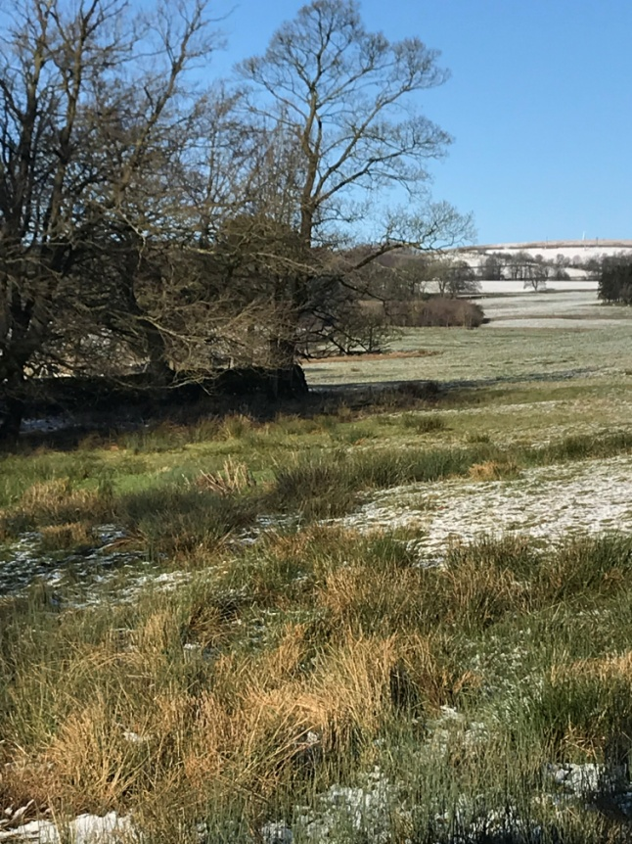
Photograph looking up the Beck from close to Skirse Gill Bridge
- The pastures are used for sheep and beef-cattle rearing and are home to much wildlife, with hares, rabbits, lapwings, curlews, skylarks and oyster catchers all finding a home here, along with feeding flocks of starlings, rooks, and other crows. The occasional deer is seen running across the land. The stream above the Bridge has had small English crayfish, minnows and bull-heads living in its waters, is a nesting area for wild ducks and the stream is often patrolled by eagle-eyed herons.

- A major feature of this area is Fleets Lane (sometimes referred to on maps as Moor Lane). This provides access to Fleets and Bordley and climbs steadily from its junction with the Hetton-Cracoe road up through Fleets and onto Boss Moor, from where there are excellent long views down through Rylstone parish to Rylstone Fell and way beyond.

- Long Gill Beck marks a sharp Western turn in the parish boundary with Hetton. It may be the W-E monastic boundary described as West Wood from Hameldon and Indritmanpits to New Common Gill and Raygill. It is a very deeply entrenched into the clay and retains some stunted thorn trees and outcrops of flagstone seen below. There are traces of a wall along the bottom which do not seem to be folds for sheep washing. To the East, the beck has many landslips of shale and flagstone. A hollow-way crosses the beck which was the old Bucker to Long Hill Farm or Hetton road.

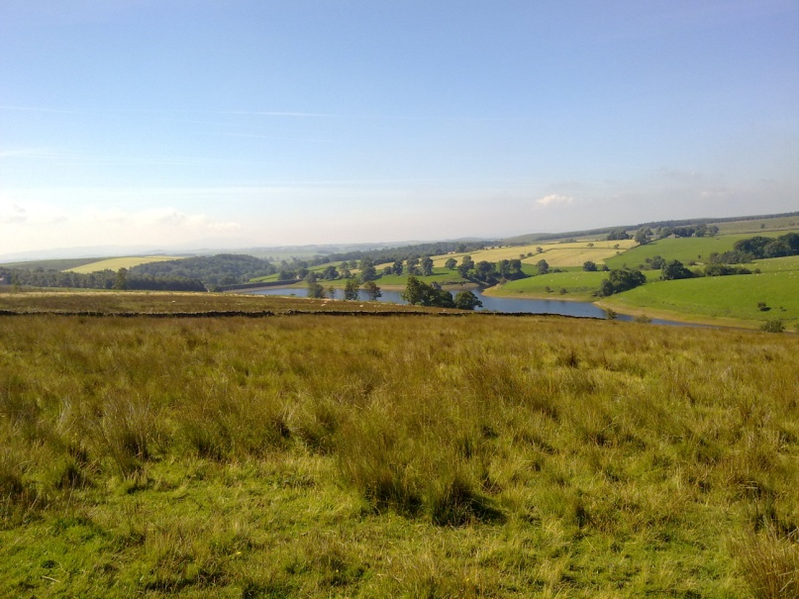
View back to Winterburn Reservoir from rough pasture in the parish beyond Longill Beck.

