Boundary Section 6:
Yethersgill to Barden Reservoir and over the Moor to Waterfall Gill

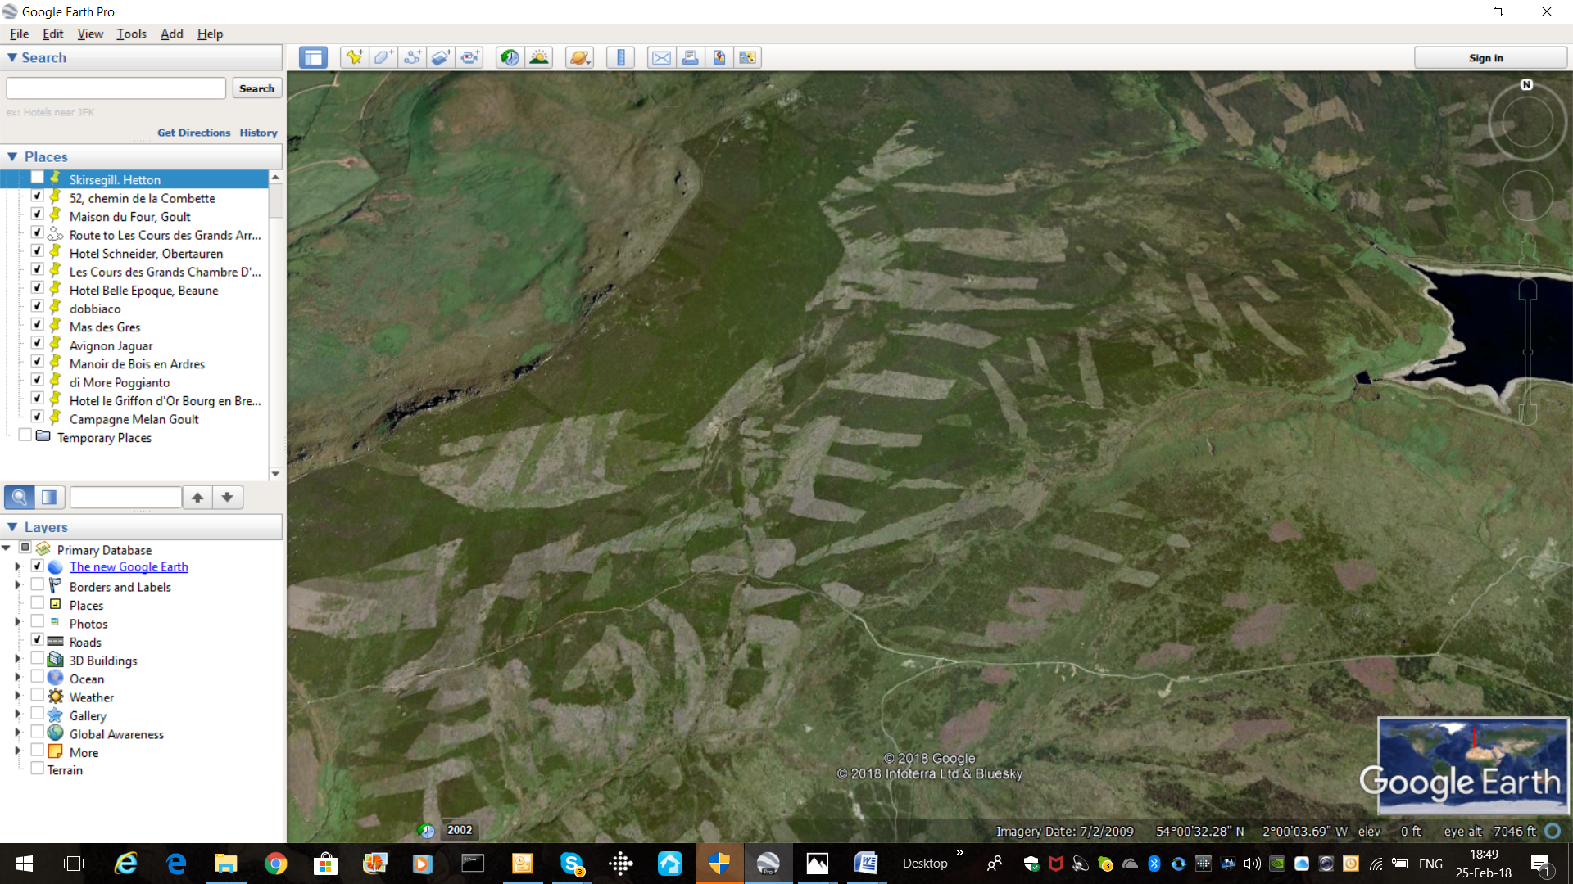
Rylstone Cross on Rylstone Fell Edge
Bridle-way across Rylstone and Barden Moors
Yethersgill
Upper Barden reservoir
Waterfall Gill

Highlights
- This section of the boundary passes over the millstone grit upland area of Rylstone and Barden (Embsay) fells. The coarse ground is covered by acid soils which support rough grassland, peats, bogs and heathers, as seen below in the left-hand photograph. It is scattered with millstone grit boulders, some of which were moved here by past glaciers, as shown in the right hand photograph.

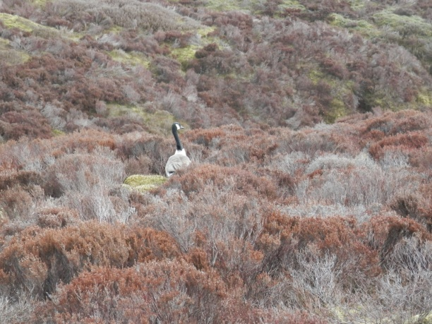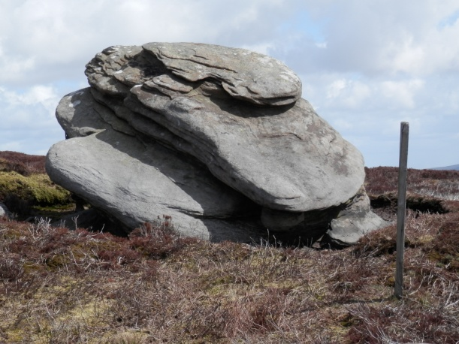

- The boundary follows Yethersgill Beck down to Upper Barden Reservoir (which feeds water to Bradford), crosses Barden Fell and the ancient, but still well-used, bridleway to and from Bolton Abbey, and descends down into the increasingly
steep Waterfall (Waterford) Gill. The land is owned by the Duke of Devonshire, a descendant of the Cliffords, and is often used for game shooting.

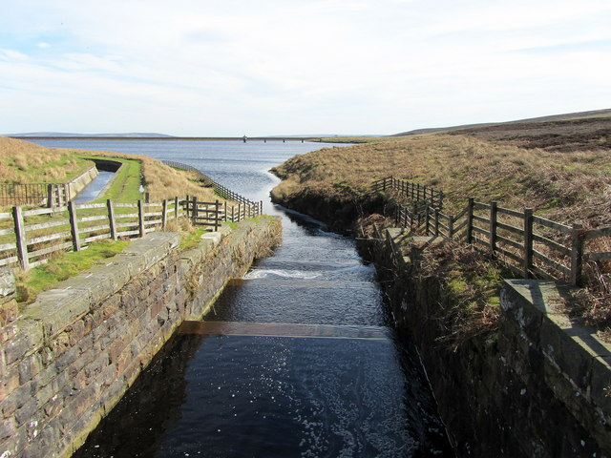
Yethersgill entering Upper Barden Reservoir.
(© Copyright Chris Heaton and licensed for reuse under this Creative Commons Licence).

- The boundary follows Yethersgill Beck down to Upper Barden Reservoir (which feeds water to Bradford), crosses Barden Fell and the ancient, but still well-used, bridleway to and from Bolton Abbey, and descends down into the increasingly steep Waterfall Gill (sometimes called Waterford Gill). This probably follows a geologic fault line from the millstone grit at its top to the shales and limestones further down. This stream line also marked the boundary between the lands of the Nortons and Cliffords in Tudor times.

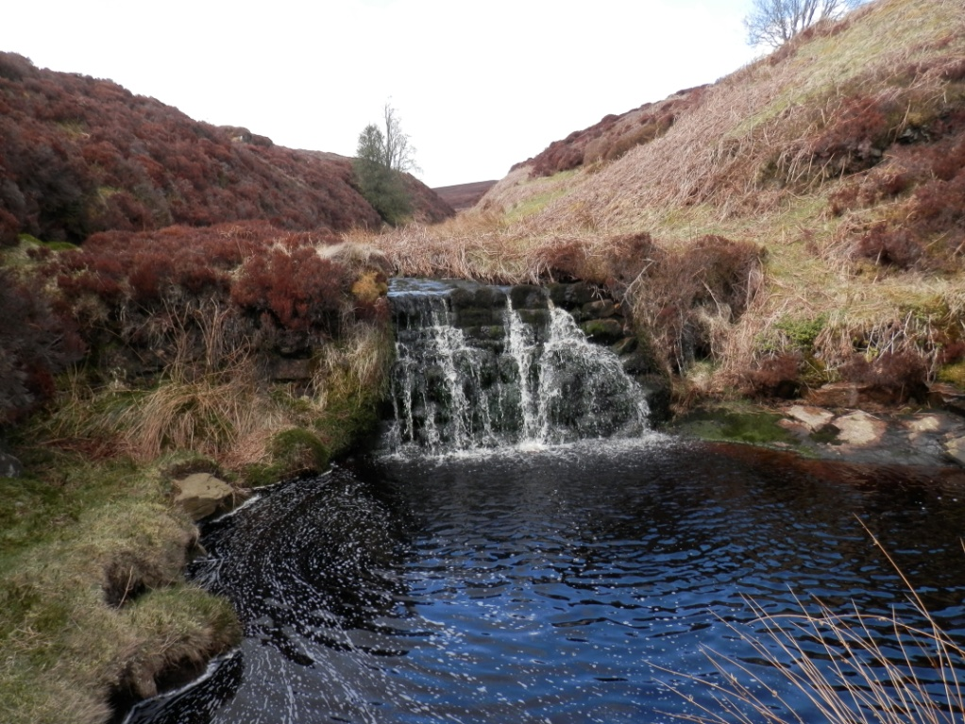
Waterfall Gill as it descends from Barden Moor through millstone grits.
- The boundaries of four parishes, including Rylstone, meet on this portion of the Fell and several boundary stones are to be seen here, as marked on the map below.

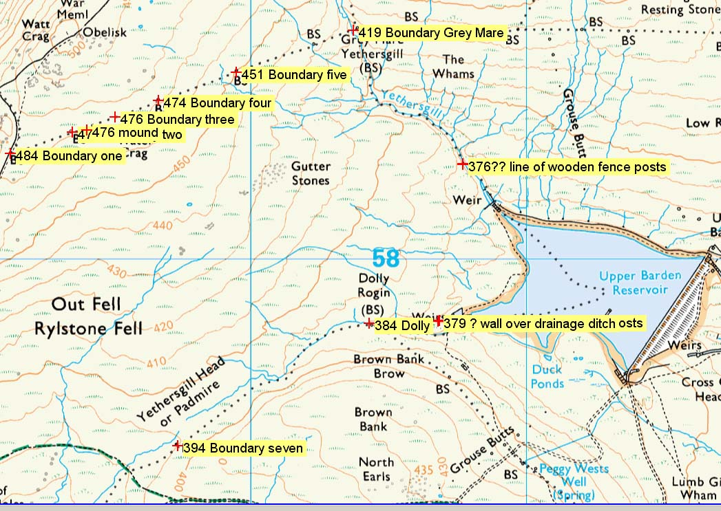
Annotated map courtesy of Jim Brophy.

- One of the most important markers is the Grey Mare Stone, which Knapp describes as follows:

'This stone is where Rylstone, Cracoe, Thorpe/Burnsall and Barden Parishes meet in the middle of Embsay Moor. It has several carvings to show the direction of the boundaries - presumably important when parishes were extracting peat from the moor'.

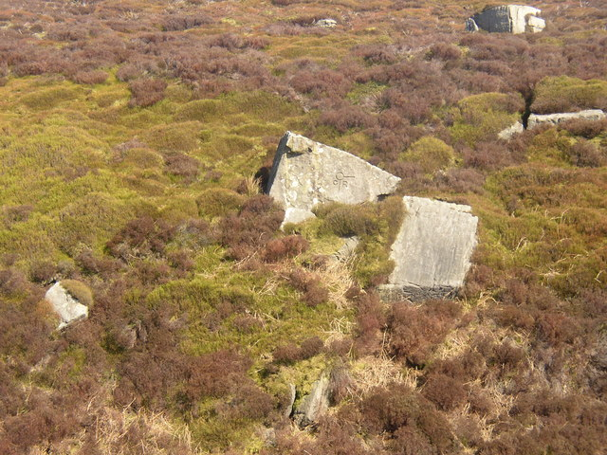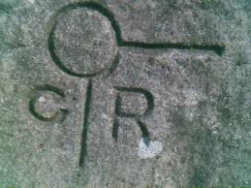
Grey Mare Boundary Stone, Yethersgill, Embsay Moor.
(© Copyright Tom Knapp and licensed for reuse under this Creative Commons Licence.)

- Another interesting boundary stone is known as 'the Dolly Roggin' (see map of markers above) which Chris Lunnon, who has examined some of these stones recently, describes as follows:
'Dolly Roggin and stone 18 (by my designation) are both marked with a Christian cross of similar proportions. They are also both marked with an unusual right-angled carving. The cross is on the Rylstone side, and thus follows the logic seen along the remainder of the boundary, probably meaning ’you are entering church territory’. The right-angle is on the Embsay side, and would thus imply that ‘you are entering territory’. The big question is, when was Rylstone land defined by this symbol? Or is there another explanation. The symbol is seen no-where else along Embsay boundary'.

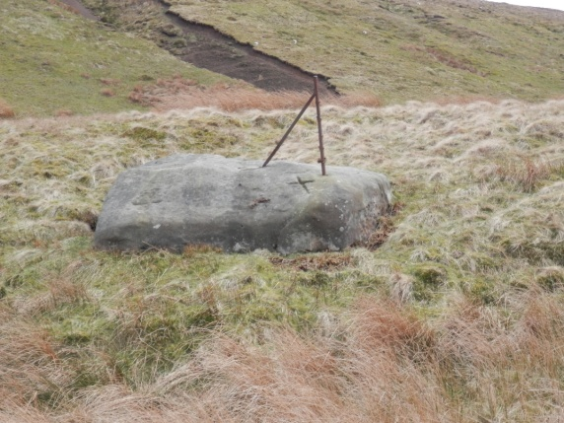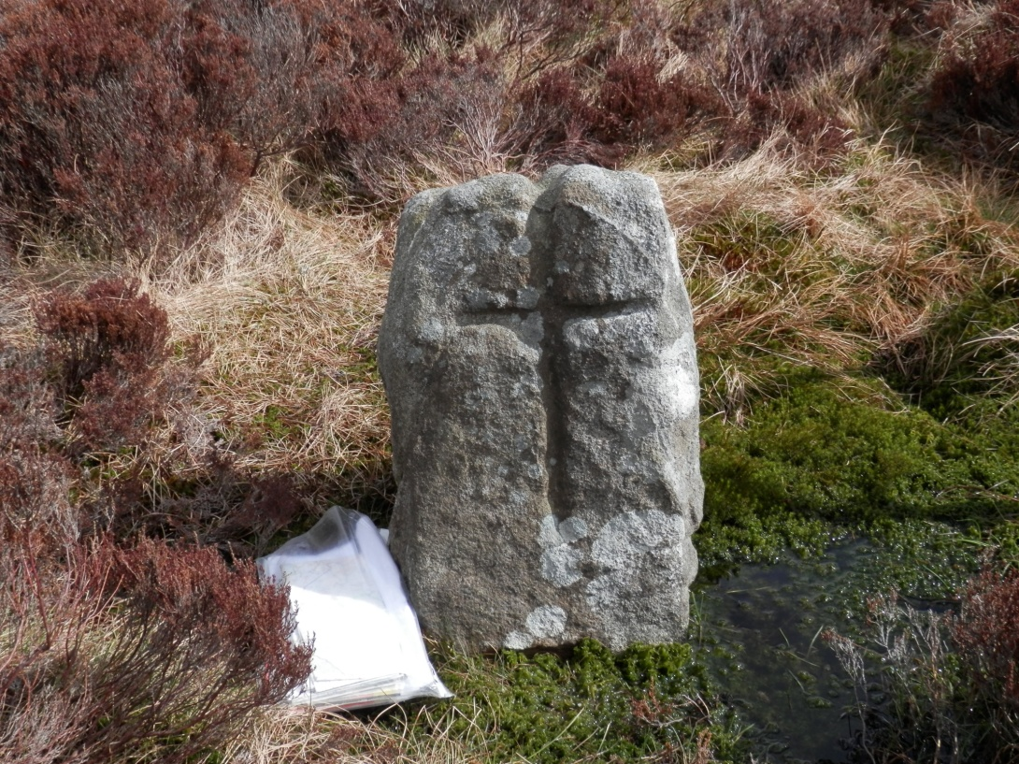
These photographs are probably of the marker stones (or similar to those) referred to by Chris Lunnon above.

- Photographs of other boundary stones are shown in the photographs below.
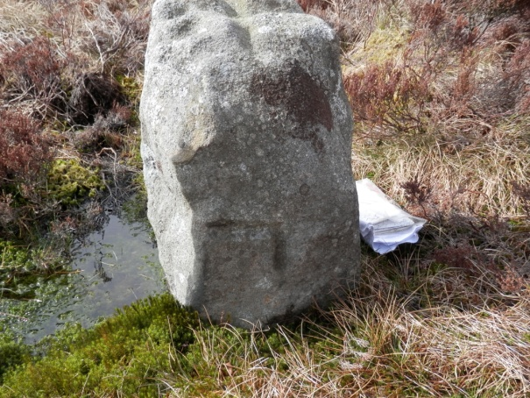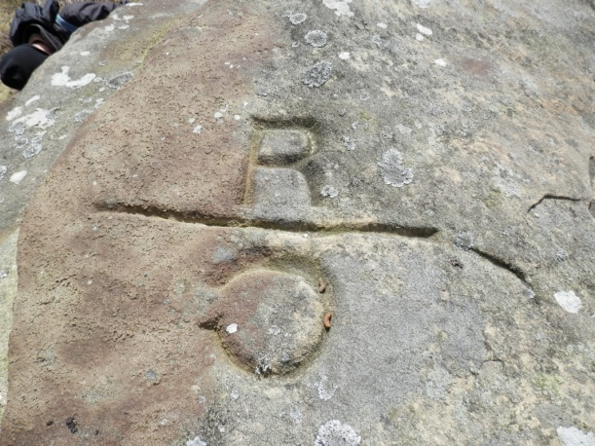
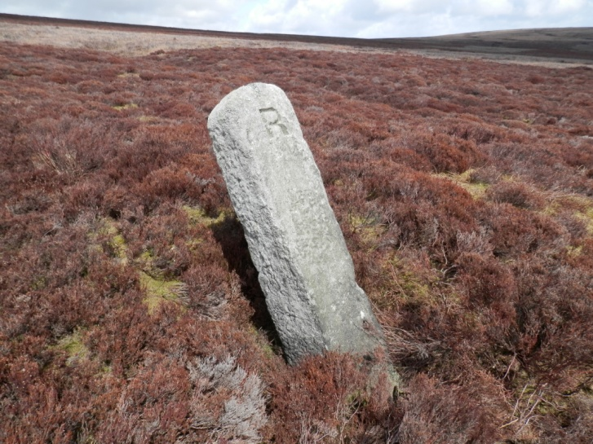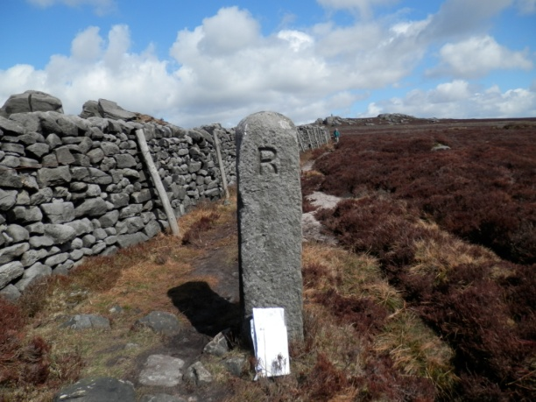

- On the very Western 'Rylstone Edge' of this section of moorland is Rylstone Cross. Originally an upright 'Stone Man' said to be a way marker on the Fell, it was rebuilt as a wooden cross in Victorian times to celebrate the Peace of Paris. It was replaced in 1995 with a stone cross and is an icon marker of Rylstone Fell and is much visited by walkers and tourists.

