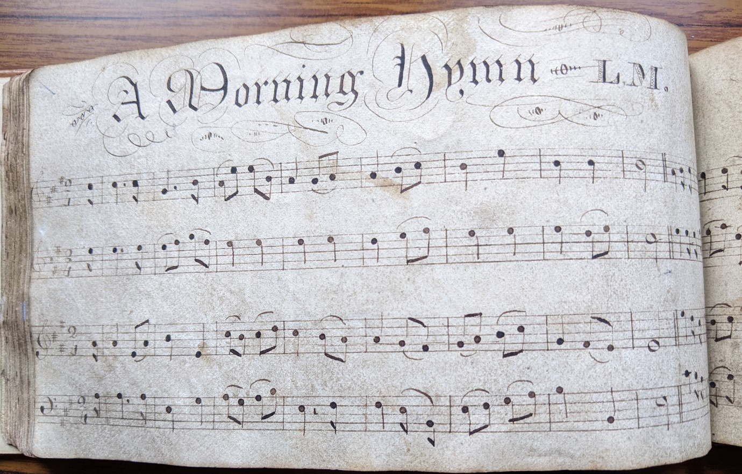
The Story Behind a Family Heirloom
Early in 2024 I ran a short course for Craven u3a called The Story Behind the Song. At the end of one session Katharine Cheney, one of the members, handed me a small rectangular book saying “I thought you might be interested in this”. Interested? I was astounded because the book proved to be a hand-written manuscript of “West Gallery” tunes. The illustration shows one of many exquisitely written pages. The four lines of music are treble, alto, tenor and bass lines running continuously through the book. The melody is usually in the tenor line, unlike modern hymns where the melody is in the treble line.
Katharine inherited the book via her grandfather John Rogers Summerskill who was born in Burnsall in 1870 and later moved to Derbyshire. Like many family heirlooms it had lingered unnoticed in the family piano stool but is now considered of local importance. Katharine has offered it to Craven Museum who have accepted it for their collection. Paul Guppy, an expert in West Gallery music, commented “What a splendid find it is …. evidence of West Gallery choirs from North Yorkshire is very sparse. I can't think of any other manuscripts from the region that have come to light”.
West Gallery music was “an amazing, powerful form of traditional music found in English parish churches and non-conformist chapels between 1700 and 1850, until it was suppressed by the authorities and driven out of the churches” (Gordon Ashman, West Gallery Music Association). In the earliest years the singing was unaccompanied but gradually instruments supporting the vocal lines were introduced.
A document from 1798 shows the purchase for St Peter’s Rylstone of “instruments, music books and other things useful and necessary to psalmody” including a “violoncello or bass violin”. The band probably played on a timber-built gallery at the west wall of the nave. The tradesmen and artisans who made up the “quire” could not have afforded to purchase their own music books. Instead, as with Katharine’s book, they lovingly copied them out in manuscript from the single copy available. However, the quires proved difficult for the clergy to manage and by the 1850’s were increasingly replaced by harmoniums, organs and surpliced choirs until, as described by Thomas Hardy in A Few Crusted Characters, “the old quire played no more”. Some moved to the non-conformist chapels which was probably the case in Katharine’s family.
Great care has gone into the title and layout of A Morning Hymn. Circumstantial evidence points to the scribe having been Katharine’s great, great grandfather John Summerskill who lived in Hetton from 1805 1882. He became the Poor Law relieving officer and registrar of births and deaths. He was probably also the returning officer for the 1881 census because the handwriting in the return for Hetton is similar to that in the manuscript book. Additionally, above his occupation in the census is written “music”. John lived very close to the Methodist Chapel in Hetton and was probably involved in the beginnings of Methodism in the area.

The book contains six anthems and fifty-seven hymn tunes. Tunes were often renamed and given local names. Craco (sic) proved to be Widdop’s Hundredth by Accepted Widdop, a wool comber and hymn writer from Halifax. Other tunes are by Thomas Clark, a Canterbury shoemaker who also wrote Cranbook later plagiarised as the tune for On Ilkla Moor Baht ‘at. Many of the tunes remain unidentified. Most have fallen out of use but there is one we all know. See if you can identify A Morning Hymn. The melody is in the tenor – third line down.
And, if you have a family heirloom of historic interest, ensure that it is preserved.
Sue Jackson

