Boundary Section 1:

North East Boundary around Lainger Beck, Boss Moor and Boundary with Bordley, Threshfield and Linton Parishes

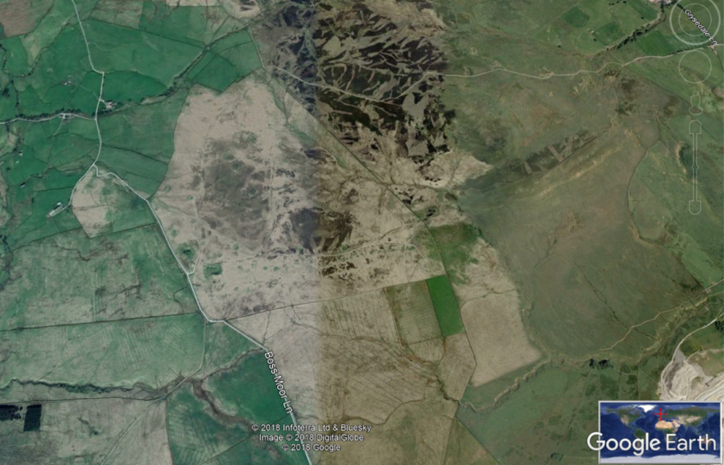
High Buckerhouse
Boss Moor
Lane Head on Lainger Beck
Swindon Quarry
Hamerton Hill - site of Ragged Stone
Black Park
Highlights:
- Important moorland boundary between the old monastic lands of Fountains Abbey (Bordley, Threshfield and Linton parishes) and the Norton/Clifford lands of Rylstone.
- Many old medieval walls with large orthostats at their base are along this boundary. Walling stones here are a mixture of millstone grit (from Boss Moor) and limestone. Some of the orthostats are limestone boulders which would be glacial erratics brought down from the North by the ice.

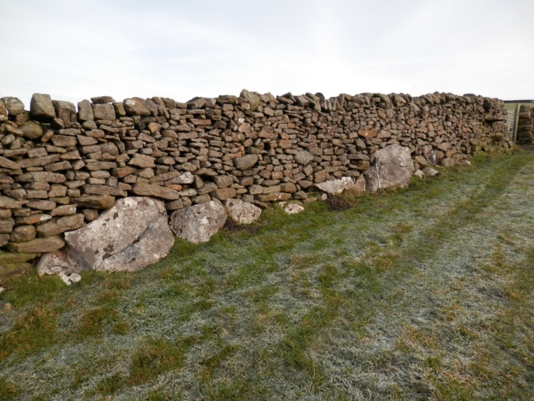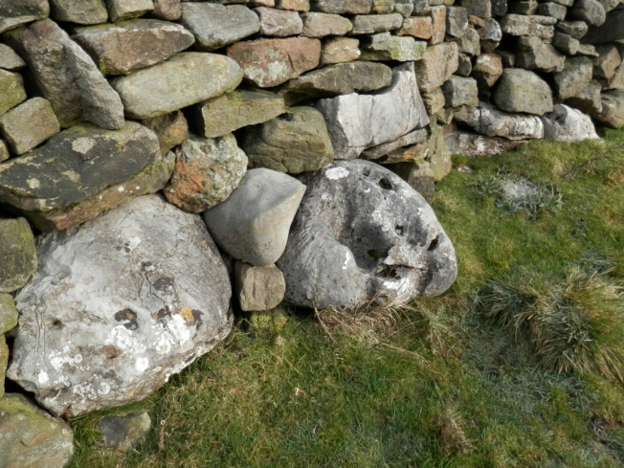

- Several ancient track-ways cross this area:
- a North-South way from Rylstone village and Skipton up to Boss Moor, Bordley, Mastiles Lane and into Malham Dale
- a North-East to South-West track from Bordley and Boss Moor to Hetton and Winterburn
- A broadly West-East route across Boss Moor to Threshfield, Linton, Burnsall and Wharfedale.

These tracks were important trading routes and used for the movement of cattle and sheep to markets in the South.

- Site of now-ruined Lane Head Inn (previously Waste Inn) on one such track-way and by Lainger Beck.

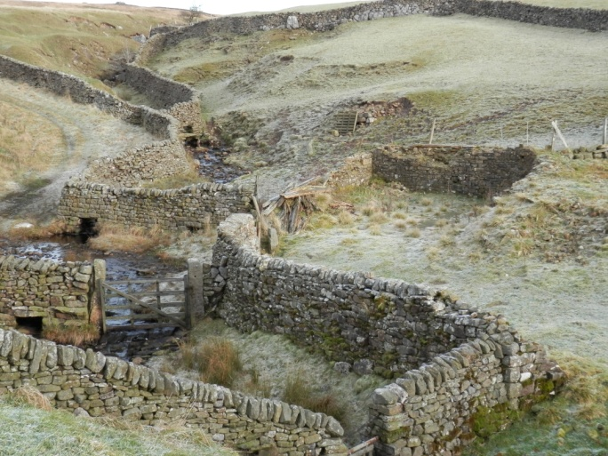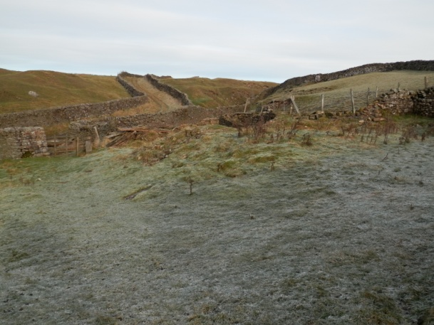

- Boss Moor was a significant upland area in previous times. It was crossed by route-ways, was the site of Buckerhouse (Bucross), an old Norse settlement and later the site of a medieval cattle trading fair each year. Its thin coal seams and thick gritstones were mined over past eras and, as a result, it is dotted with numerous old quarries and coal pits - some going back many centuries - which mark its industrial past.

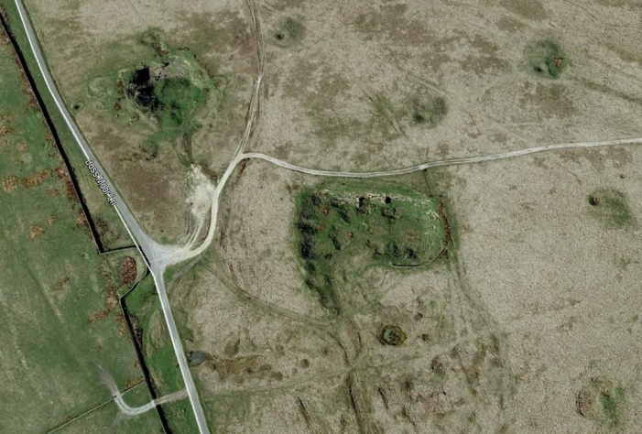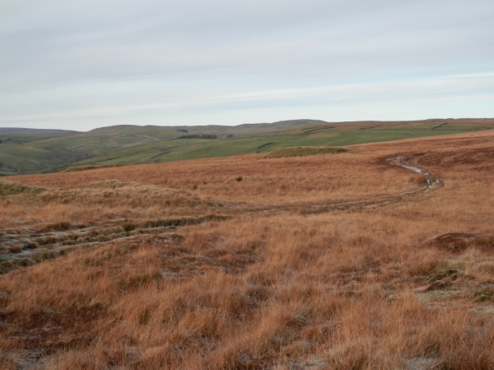

- Site of old 'Ragged Stone' - a tall, monolithic erratic block of weathered limestone on Hamerton Hill, whihc marked the boundary with Threshfield parish. It is by the old pack-house route between Boss Moor and Threshfield. It may have stood upright but animals have worn away the foundations and it may have toppled.

