Boundary Walk 1: North East Boundary around Lainger Beck, Boss Moor and Boundary with Threshfield Parish

Highlights:

- Important boundary between the monastic lands of Fountains Abbey and the Norton/Clifford lands.
- Many old medieval walls with orthostats at their base
- Site of now-ruined Lane Head Inn.
- Boss Moor is dotted with numerous old quarries and coal pits - some going back many centuries.
- Site of old 'Ragged Stone' - a tall, monolithic erratic block of weathered limestone by old pack-house route between Rylstone and Threshfield.

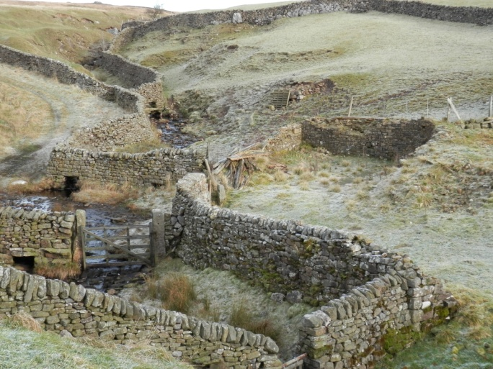
Ruins of Lane Head Inn

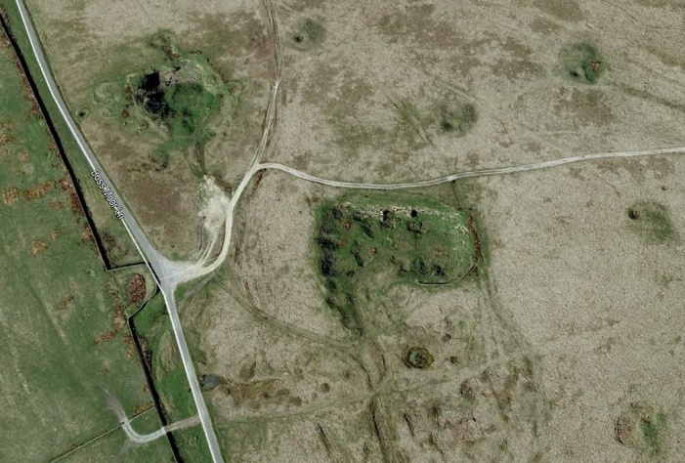
Old quarries and coal pits on Boss Moor
Picture of Ragged Stone?

