Boundary Section 12:
North West Boundary around Buckerhouse Farmstead and Pastures to Lainger

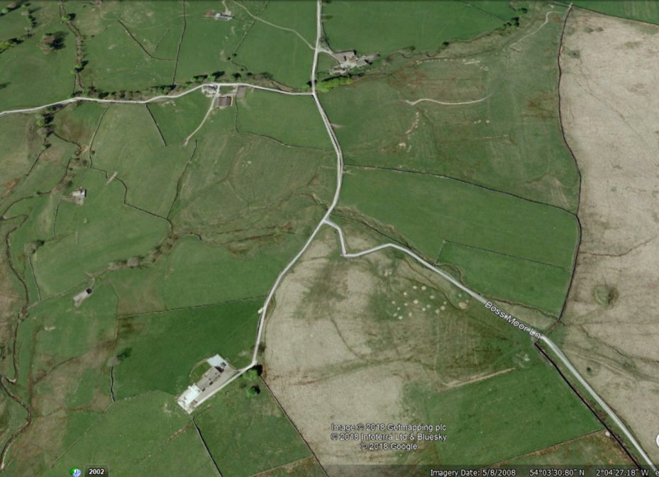
Bucker House Laithe
Boss Moor Lane
Low Bucker House
High Bucker
House
Lainger Beck

Highlights
- This section of boundary follows Hetton Common Beck Northwards from just above Winterburn Reservoir to Lainger Beck, at which point it turns right and follows this stream North Eastwards past Lainger House to Lane Head. The boundary land here is all coarse upland pasture or moorland.

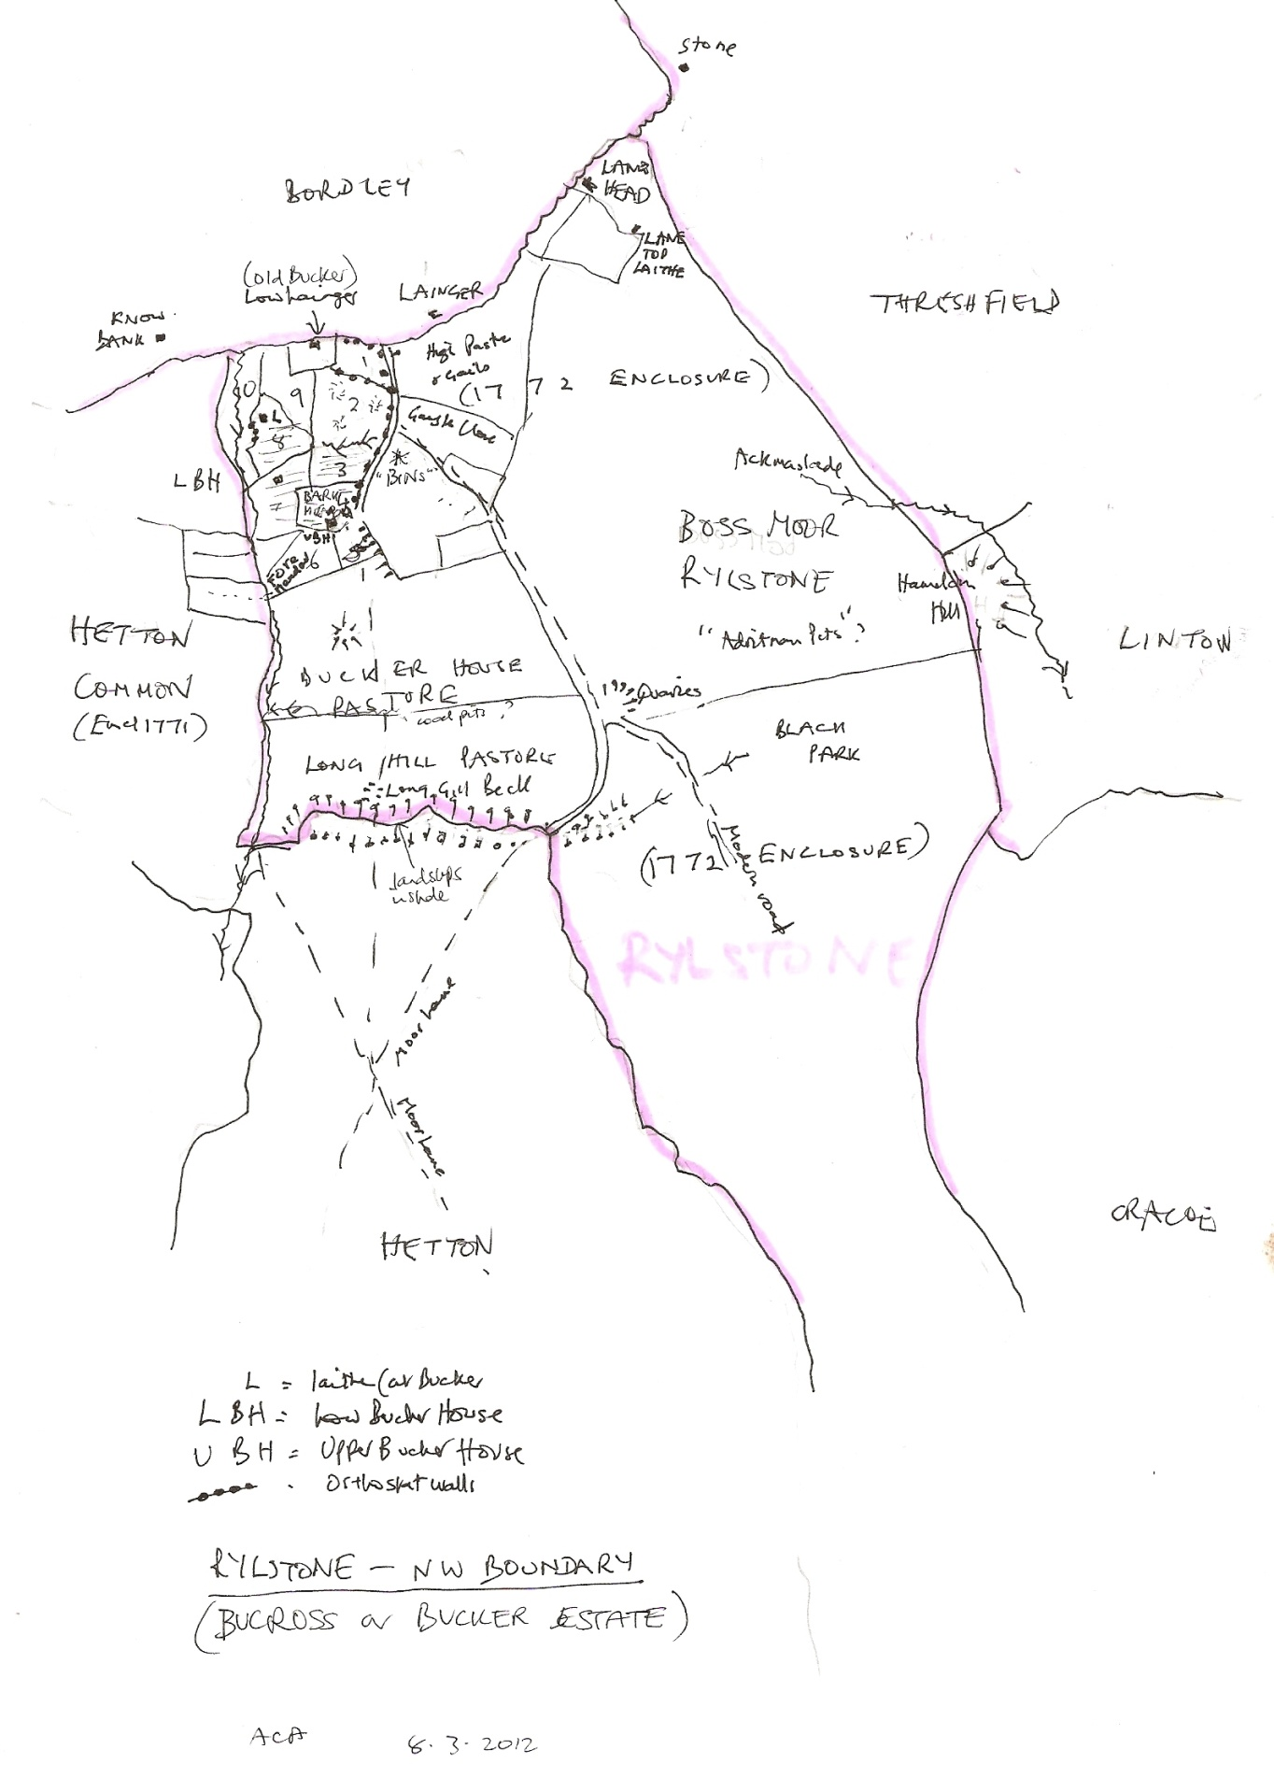
Sketch map by Alison Armstrong
- The key feature of the area is Buckerhouse - a derivation of the old name of 'Bucross' for this Norse outlier farming settlement within Rylstone Parish.

The centre of this ancient farmstead is High Bucker House, which is now a recently renovated house. This has been described after a project survey as being originally:

'an 18thC barn to which has been added c 1800 on the uphill side a double pile house with central doorway and rear stair window. The house has flat-faced mullioned windows. Added to the house on the east is another bay that may have been a granary and stable or cart house. It has been given modern windows like those of the house. A small low detached building remains to the east; possibly a piggery or similar outbuilding. Before conversion in 2011 the barn had a 19thC roof truss. There are several dressed gateposts with margin-dressing in Georgian style'.

Low Bucker House, once a house, but now a barn, is described as follows:

'This appears to be the older house and its position near old orthostat walls and a beck may indicate a building here from Scandinavian times. The house stands near a deep gill and stream. It was a linear house and barn but is now all used for livestock. The plain stone surrounds are 19thC. Inside, the house appears to have had narrow back rooms probably for stair and dairy. There is still a fireplace c1800 with brick hob remains upstairs. A similar larger fireplace with deeper stop is in the house-body below. At the back are rear rooms have a 3 light and 2 light mullions. There are straight joints showing where the house once extended further west and included what is now the barn cart bay. The barn is now of two bays with a cart entry or was it once a granary attached to the house?

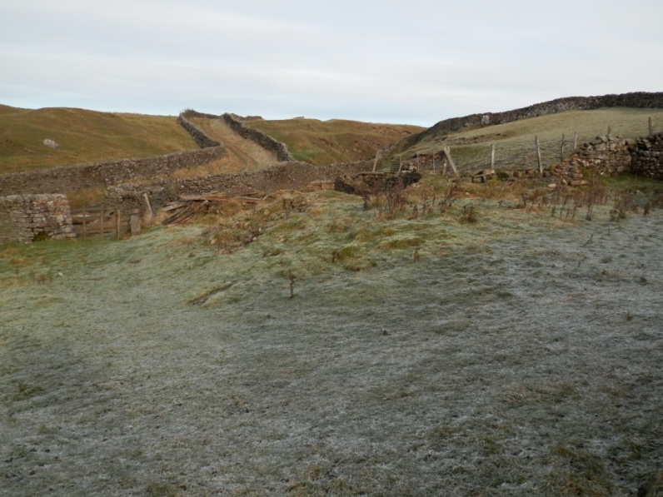

- The township boundary between Rylstone and Bordley, is along Lainger Beck. On the Rylstone side of the beck, until Lane Head, is a deeply hollowed track (see above photograph) which was a major routeway in the 19thC from Weets Top on Boss Boor, East to Linton and Burnsall. There is an old ford, just below Lainger House on this old pack-horse route. Monastic accounts show the old boundary of Fountains Abbey's lands with those of the Norton’s Rylstone lands was further south in the late 13thC.

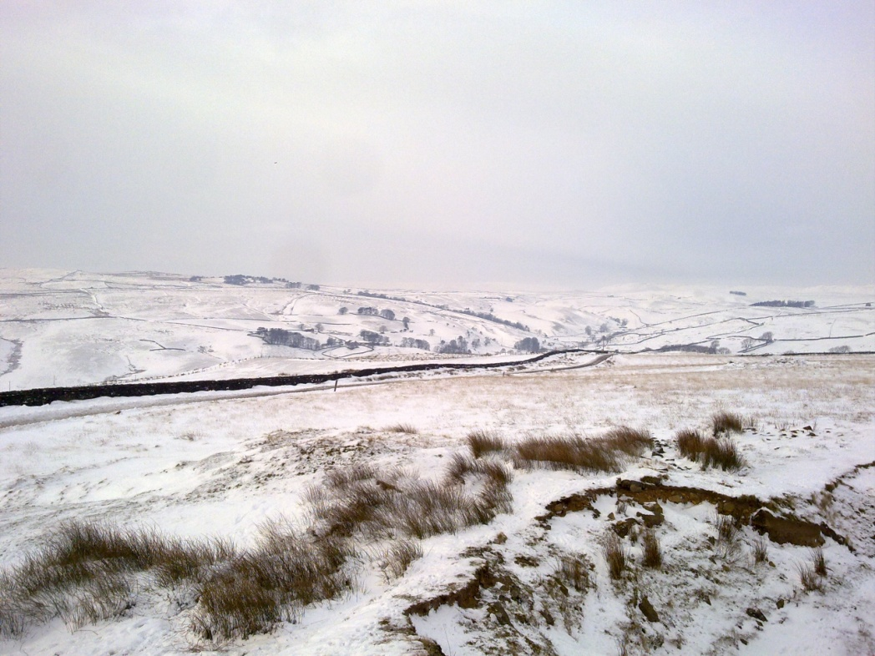

Snowy picture looking from Weets Top, Boss Moor across Boss Moor Lane towards Bordley.

