Barrow and Tree Burial at Scale House, Rylstone

British Barrows – Canon Greenwell Oxford 1877 p.375
Rylstone – Scale House Barrow Greenwell excavated the barrow in 1864.
(We are grateful to the late Richard Hartland =RH for some additional information relating to the barrow and similar coffin burials personal communication)
During the years 1860-69 Captain Blake, steward to the Earl of Burlington, resided at Scale House, Rylstone. The adjoining Scale Hill Farm, on which the barrow stands, would be within his domain. In 1863 the centre of the barrow was dug into by the farm tenant, breaking through the coffin and disturbing part of its contents. The following year, Canon William Greenwell, arrived on the scene to make as good an excavation of the previous year’s dig as the techniques of the period allowed.

The mound is 30 feet in diameter, 5 feet high, made of clay and with a shallow trench close to the base completely encircling the mound. Currently its diameter is almost 50 feet with a smooth profile and no vestige of a ditch, so it has been “landscaped.”
Immediately below the surface of the barrow, at the centre, was a layer of carefully arranged flat stones, about 6 feet in diameter. Under these the clay was firmly compacted and rested on a thin stratum of dark-coloured earthy matter which was very full charged with charcoal. Interestingly, at Grisethorpe, a similar coffin was excavated in 1834 (see Williamson, 1872 and 1896?) with a layer of branches overlaying the coffin, so might the ‘charcoal’ at the Scale House barrow be the remains of branches?
Beneath this charcoal horizon was a further layer of finer clay or rather clay which appeared to have undergone a process of tempering. Below this finer clay and carefully embedded in it, was an oaken coffin laid upon clay and to some extent supported by a few stones, the whole being placed in a light hollow sunk below the surface of the ground.
The coffin was formed of the trunk of an oak tree split in two and then hollowed out (see Photograph 1). It was 7¼ foot long and 1 foot 11 inches wide; the trunk had been cut off at each end and then partially rounded, but on the outside no attempt at squaring or other workmanship had interfered with the natural surface of the timber. The hollow within was 6 feet 4 inches long and 1 foot wide, roughly hewn out, and still showing the marks of the tool employed; the ends inside were finished off square. It was not possible to make out the nature of the tool which had been employed, but the appearances warranted the conclusion that it had been a narrow-edged metal implement.
The coffin was very much broken in consequence of the disturbance before mentioned; it was, however, still sufficiently entire to allow its arrangement to be seen. It was laid north and south, having the thicker end - where the head of the enclosed body no doubt had been placed - to the south. The body had entirely gone to decay and nothing was observed which might have formed a constituent part of it except an unctuous whitish substance, which chemical analysis has proved to be of animal origin.
It is noteworthy that in Northumberland several wooden coffins like this were found near Featherstone Castle, Wyden Eels, in a wet situation, with bones entirely decayed except for one instance where bones remained, resembling old leather (see Grinsell, 1953?). The hollows within the bones were filled with the mineral Viviamite. Bones found in peat bogs sometimes are in the same condition, the change in them is due to the action of the carbonic acid generated in the peat.
The corpse at Scale House had been enveloped in a woollen fabric, enough of which remained to show that it had reached from head to foot. It was very rotten, and partly on that account, and partly by reason of the infiltration of the earth which had found its way into the coffin through the breakage occurring when the barrow was first opened, and which had become mixed up with the cloth, it was impossible to recover any but small pieces of it (see Photograph 2 below), or to prove whether the body had been laid in the grave in its ordinary dress or simply wrapped in a shroud. It is on the whole probable that in this case, as in those of some tree-burials discovered in Denmark, the person had been interred in the dress worn by him in daily life, though perhaps it may be alleged that the absence of anything like a button or other fastening is rather against that view.
The material is now of a dark-brown colour, due most likely to the tannin in the of the coffin; whilst to the acid generated in the decaying wood and set free by the percolation of water is perhaps to be attributed the total disappearance of the bones. There was nothing found in the coffin besides the woollen stuff; nor, with the exception of pieces of charcoal and some burnt earth, was anything met with foreign to the ordinary material of the rest of the barrow.
In the absence of any associated articles in the coffin, or of potsherds or flints in the mound itself, it is difficult to assign a precise date or period to this remarkable burial. But if we take the general shape and construction of this barrow into consideration, as also the encircling ditch, the presence of charcoal and other indications of burning, I see no reason for hesitating to refer it to the people whose usual custom it was to place the body of the dead person in a stone cist or in a grave within the barrow; merely supposing that in this and in a few other instances they departed from their ordinary practices in favour of a wooden receptacle.
And when we compare this burial with some others found in this country, and with those which have occurred in Denmark, we can further have little doubt about attributing it to the time when bronze was in use for weapons and implements. The mode of interment in the trunk of a hollowed tree placed within a barrow is no doubt rare, although burials in cleft and hollowed trees placed in the ground without any super incumbent grave-mound are not so uncommon. Many of them, however, are not to be referred to a very early period, and indeed probably belong to a time several centuries after the Christian era.
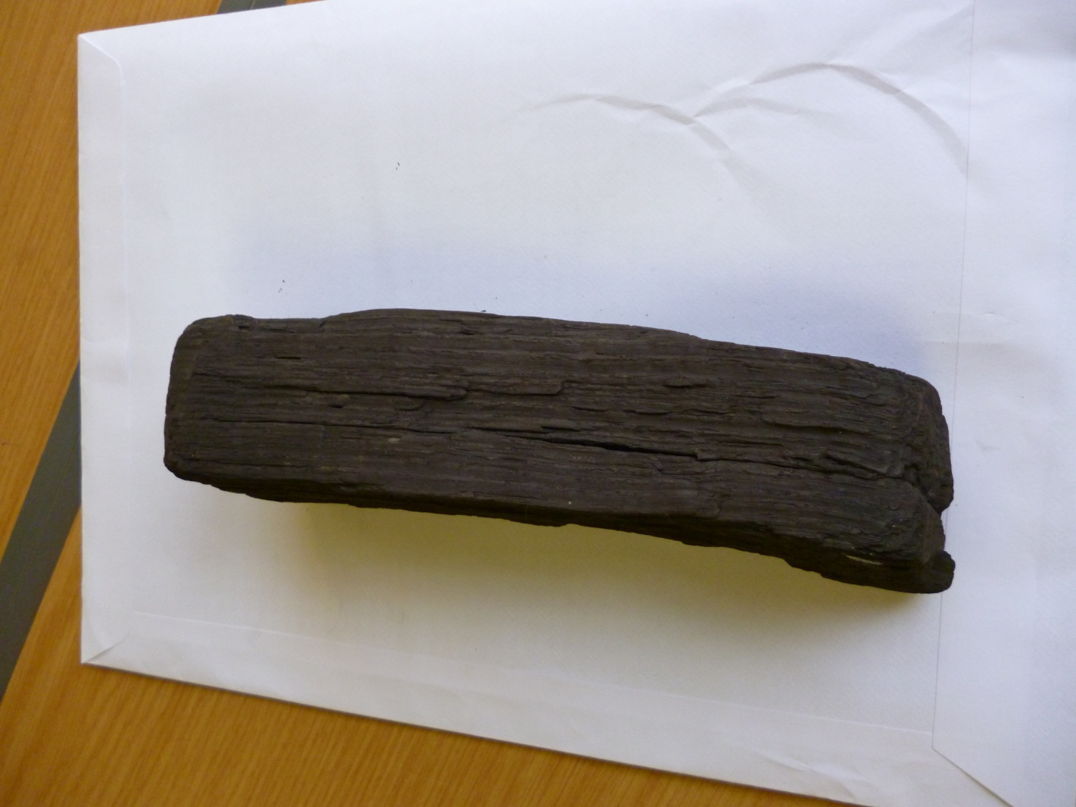
Photograph 1. A Piece of Timber from the Tree Burial. Craven Museum, Skipton.

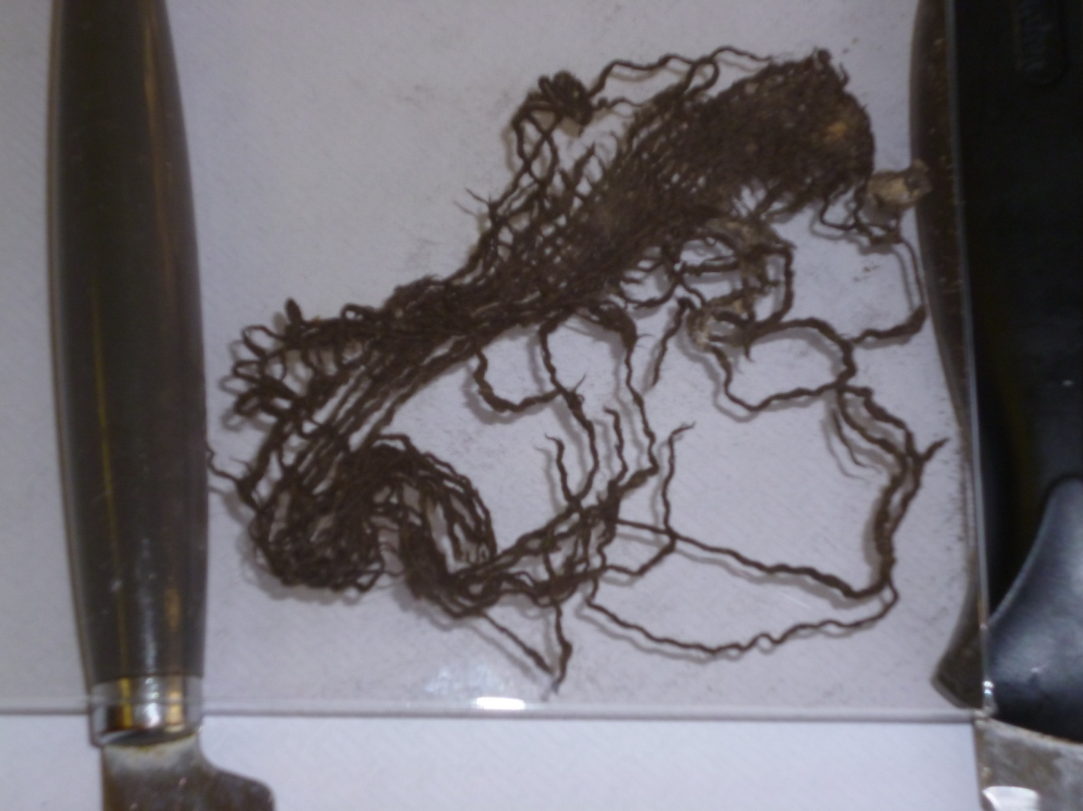
Photograph 2. Remnant of Woollen Clothing from the Burial. Craven Museum, Skipton.

References
1. Greenwell, W. and Rolleston G. (1877). British Barrows. Oxford: Clarendon Press.

2. Williamson, .C. (3rd Ed. 1872). Description of the Tumulus Opened at Gristhorpe Near Scarborough. Scarborough: S.W. Theakston.

3. Williamson, C. (1896). Reminiscences of a Yorkshire Naturalist. London: George Redway.

4. Grinsell, L.V. (2nd Ed. 1953). The Ancient Burial Mounds of England. London: Methuen & Co.

RH: The Grisethorpe Tree Trunk Coffin was at that time displayed in Scarborough Museum.

