Boundary Section 9:

Calton Gill Beck, via Clints Quarry to Hetton Beck and Mill

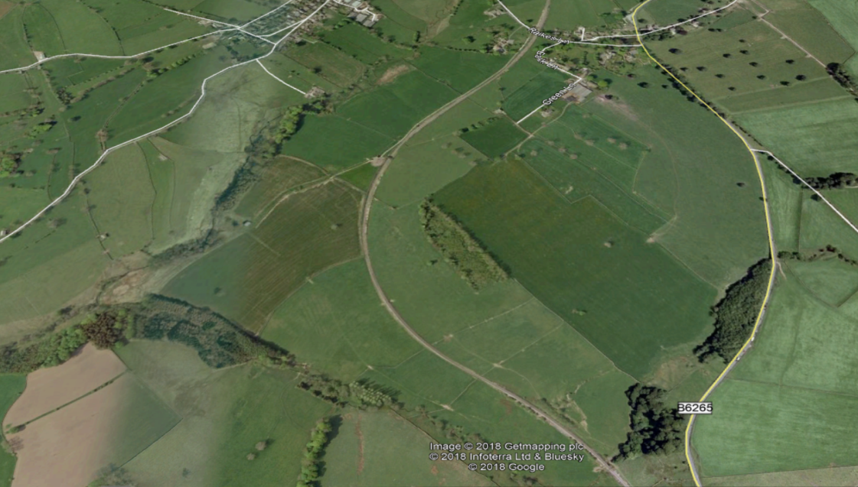
Calton Gill Wood and Beck and site of old tile kiln
Site of old Hetton & Rylstone mill on Hetton Beck
Clints Limestone Quarry

Highlights
- This boundary section follows two streams: down Calton Gill Beck which flows North West into Hetton Beck at the juncture between Rylstone, Hetton and Flasby parishes. It then follows Hetton Beck, which flows South West to Flasby, Eshton and finally into the Aire river system. Whilst the boundary area starts in open fields, it soon becomes hidden in tree-lined banks and small woods.

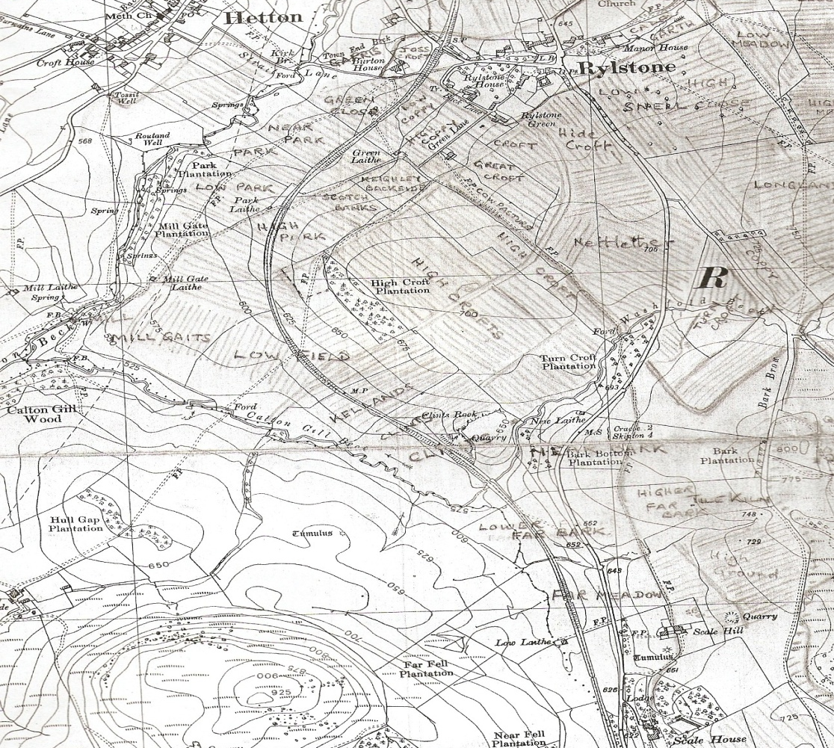
Richard Harland’s map with some field names on c1910

- To the East and North of the boundary, framed by the two streams, are pastures and meadowlands which offer some of the best agricultural land in Rylstone parish, some of which was given over to arable crops before the 19th century. The old field system (C 1900) is shown on the map above which also depicts the old patchwork of rigs and furrows in the fields made by the old method and direction of ploughing.

- Clints Rock Quarry is a small, disused limestone quarry situated just by the railway line as it emerges into the valley lands before Scale House. Little is known about it, when it was in use and who now owns it, but some of its limestone may have been used in the construction of the railway line. It contains some well documented Carboniferous-age fossils, mentioned in several geological memoirs.

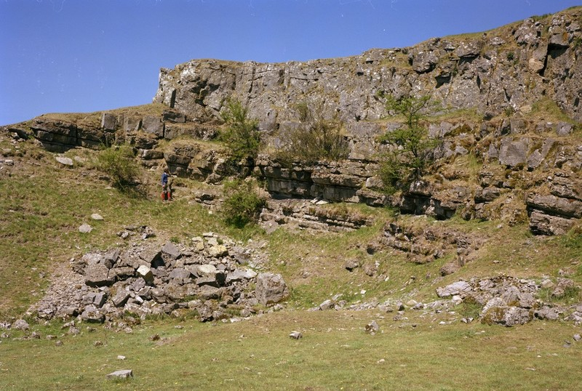
Clints Rock Quarry

- An extract from Helen Ward's diaries (available from the Brotherton Library, Special collections at Leeds University) reveals the presence of an old lime kiln, hidden in the wood along Calton Gill Beck. There is one mention in a related text that limestone from nearby Clints quarry was brought here. Small lime kilns were used to turn limestone into lime for the fields and for lime mortar for white washing building walls. These small kilns are scattered across Dales' parishes.

A project visit to the site recorded the following:

'Stone gateposts marked a track into Calton Gill Woods which allowed us access to the beck. The beck flowed over rock outcrops (limestone?). The ford shown in 1850 still exists. We also discovered a post-1850 limekiln (SD 9615 5765) with its access over an arched bridge. The field wall formed the township boundary here, so the kiln was perhaps just in Flasby. The kiln front had recently fallen exposing the back of the draw arch. A wire fence on the top of the kiln was where lime and coal would have been loaded'.

- A second industrial artefact further along the boundary - on Hetton Beck - is the site and remnants of the old water-driven mill which was shared by Rylstone and Hetton parishes. It was of early medieval origin and was originally a corn mill, and later a cotton spinning mill. It ceased operation early in the 19th century and only a few stones remain, of which one is shown below.

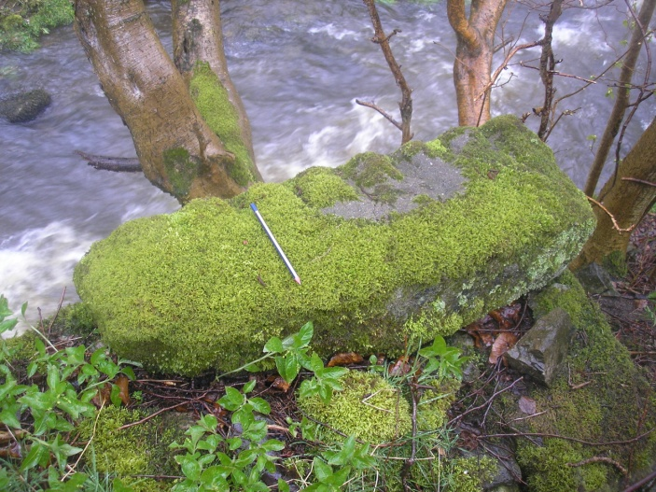

A further description of the site follows:

'...The earthworks seen include two rectangular building platforms on the south of the beck and a deeper narrow pit on the NW end which was probably the water wheel pit. Above the pit is a long level cutting quarried in the limestone which was almost certainly a leet taking water from the beck higher up. A winding channel from the wheel pit site was probably the outflow back to the beck'.

When operational, Hetton mill would have looked rather like the drawing below.

