Boundary Section 4:

From Old Hall Farm, Rylstone to Hall Fell Edge, on Rylstone/Barden Moor

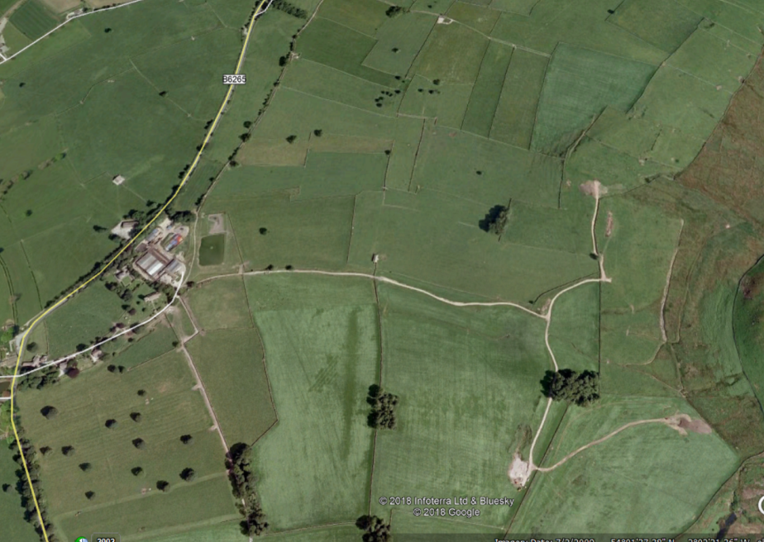
Chapel Lane, ancient trackway
St. Peter's Church
Site of Old Hall
Trackway from Rylstone to Bolton Abbey and Skipton
Supposed site of Norton's
deer park

Highlights
- In this section, the boundary starts at Old Hall Farm and cuts across the Eastern pastures of the Parish via Crutching Close and up onto the Hall Demesne, part of Rylstone and Barden Moor.

- The old map above reveals the site of the Norton family's late 15th century manorial hall and grounds, built by John Norton. It is now covered by buildings of Old Hall Farm. Shown below is a depiction of Nortons' Old Hall by Birket Foster in The White Doe of Rylstone by William Wordsworth.

From the 1867 edition of the White Doe of Rylstone, published by Bell and Dandy. Digitised by Google and available on the University of Illinois website).

The surrounds of the Old Hall are shown below in a photograph by the Yorkshire Dales National Park, where the old manorial fish pond by the once extensive 'pleasure gardens' are still visible. St. Peter's Church is close by.

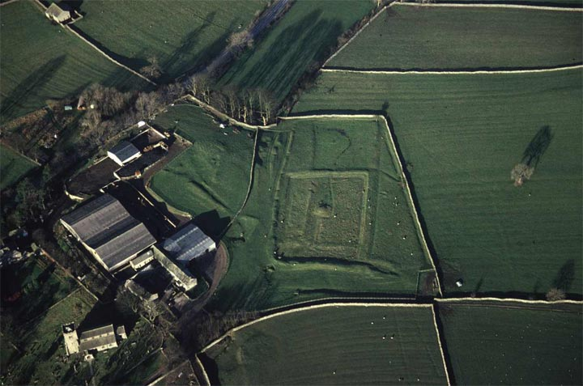
Site of Nortons' Old Hall
St. Peter's
Church
Fish pond in Old Hall gardens

- Below are two images of St. Peters Church in the 18th and 21st centuries
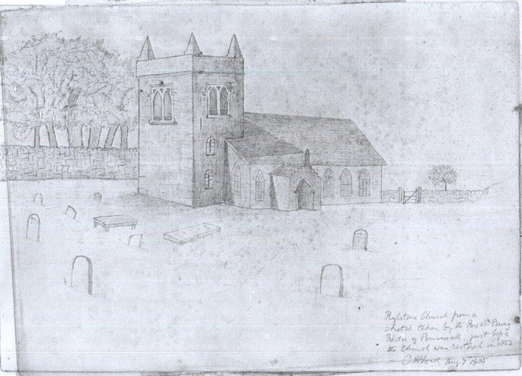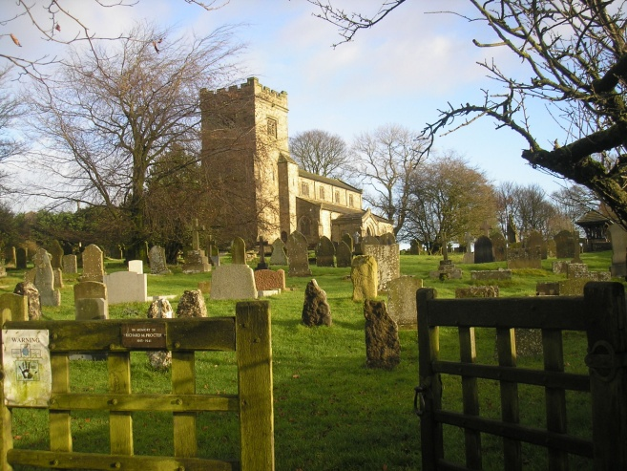

- From North East of the Old Hall, the boundary goes around the old fish pond, through former arable fields and along the edge of Crutching Close (Crutching means a cairn). The landscape is now one of 19th C copses and enlarged fields. Isolated trees mark older (16/17th C enclosures) and the hedgerows and banks that have gone. The boundary then rises, ever more steeply to the Hall Demesne from where there are good views back to the village. Below are two photographs looking towards Rylstone village, Old Hall Farm and St. Peter's Church from the slopes of Rylstone Fell.

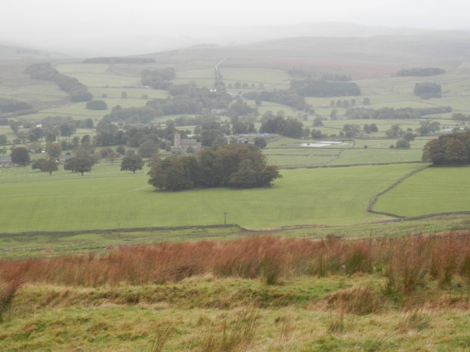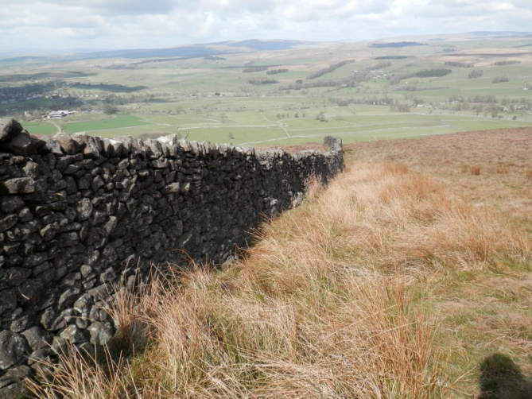

- The Hall Demesne is thought to be the site of the Nortons' deer park, which caused such ill will with the Cliffords. Below are two views up to the Fell and Rylstone Cross, with the banking clearly visible, which is thought to be one edge of the old deer park.

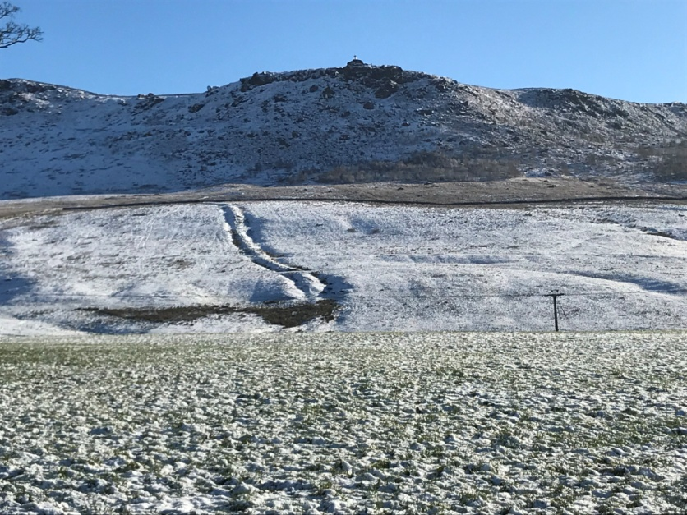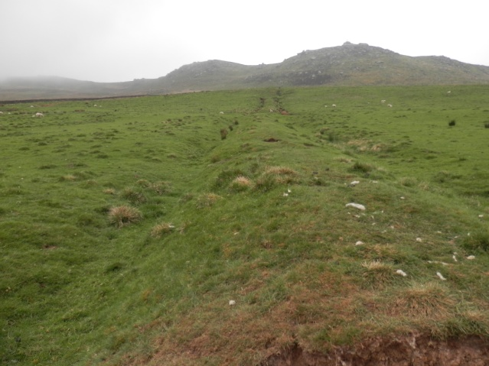

- The boundary, as it rises onto Rylstone Fell Edge in the Hall Demesne, follows old walls of substantial construction. Below are photographs of sections of these walls on the Eastern boundary, with ancient large orthostats at their base, showing that they had been built on more ancient constructions. Local walls were built of the most local materials to hand - in this case millstone grit - and small quarries or depressions from where the stone was excavated are still visible on the slopes of the Fell.

