Reverend Bury’s Scrapbook

Rylstone
Hitherto we have been speaking of Townships which im-
mediately adjoin to that of Burnsall. Those which follow
are either wholly, or in part, divided from it by the Parish
of Linton.
Rylestone is situated about midway between the valleys
of the Aire and the Wharfe. It derives its name from the
Danish “Ryll, rivus tacitè fluens,” as it is situated among
the forks of several inconsiderable brooks, all of which fall
into the Aire, excepting one, which finds its way eastward
into the Wharfe.
Rylstone gave a name and habitation to a family perhaps
of the first antiquity in Craven, as there is reason to suppose
that William de Risletona, who occurs in the first Charter
of Cecilia de Romille, was the William, son of Clarembald,
mentioned in the Black Book of the Exchequer, and undoubt-
edly a Saxon. No name occurs more frequently in the Craven Charters: about a century after the above transaction
we meet with the name of Eustace de Rillestone; and
afterwards Sir Elias de Rillestone. The Manor continued in
the name until it expired in Isabella, daughter and heiress of
John Rillestone Esq., who married Miles, son of Wilkin Radcliff,
base son of William Radcliff, Esq. of Todmorden and Merley
in the County of Lancaster. The following petition from this
person, or his son, to Cardinal Beaufort, is too curious a document to be suppressed, and may therefore be indulged with a place here.

“To the full Rever’d Fader in God and right gracious Lord
Bischope of Winchester, Cardinal of England.

“Besechen mekely y^{r} servitours William Radclyff y^{e} younger and
his cozen Worsley, of y ͤparish of Cliderowe, in the countie of
Lancastre, y^{t} wheras Thomas the sonne of Sir Thomas Radclyff,
of y^{e} said countie, knight, be great ordeannance and fore-
casting against y^{e} peace of o’r suveraine Lo the Kinge, with
y^{e} numbre of XXlV harnaysed men, made violent sawte
upon your saaid besechers, and them greveosly maimed
and wounded unto p’ll of dethe. In which debate y^{e}
said Thomas, atte defence of your saite besechers, was
sleayne, as it is openly knowen to y^{e} R’t Honnorable
Lordes, y^{e} Lorde of Duresme and y^{e} Lorde of Salesbury; and
then, by y^{e} ordinaunce of y^{e} said Lorde of Salesbury, w’ch
had al y^{s} matere hold in his rule, apoynted Thomas
Harington, Esquyer, and Thomas Urswicke, Esquyer,
as attrabutors to bee in meane and indifferent in
y^{e} seide metere, we (were) through y^{m} apoynted
demed and awarded, by scripture indented, under their
seales, rehersing, that y^{e} saide Thomas, in his seide
assaute makyng, was sleyne, in y^{e} defens of y^{e}
seide besechers; and notwythstanding y^{s}, y^{t} y^{e} seid
besechers shal pay Xl markes in moneye, y^{e} w’ch y^{s}
to greavose and importable charge of y^{r} seide besechers,
w’thout they had, or myght have, y^{e} graciouse almes of
supportation and refreshing of Lordes. Wherefo pleas
yt your noble Lords’p, of y’r gode grace, in consid’acion
of y^{e} p’misses, to refresh and releve y’r seide besechers
w’th y’r moste graciose almes, after y’r gode plesure,
atte reverence of God and in waye of charitie.”

contd.
Here is a very late instance of the ancient
Blodpite, or pecuniary compensation for homicide. The
Ratcliffs were zealous retainers of the house of Lan-
Caster, and this military prelate, it may be, felt no
repugnance to relieve a brave man of that party,
though he came before him with hands dipped in
blood.
The descent of this branch of the Radcliffs is
as follows:

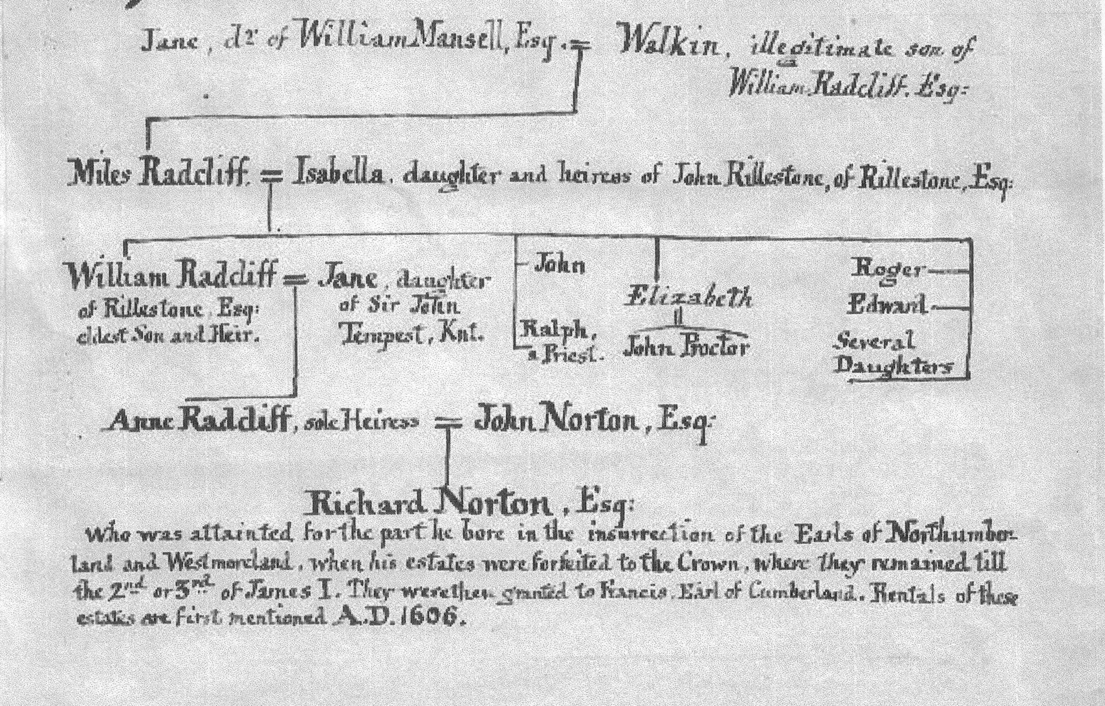

NORTON LANDS
Rilestone Manor

Measure 1010 A. 10 P.
Old Rents received £68. 14s. 2d.
Clear yearly value £139. 17s. 8d.
Fee simple at fifteen years purchase £3128. 17.s 6d.

The ancient Manorhouse was now in decay. Immediately
adjoining lay a close, called the Vivery; so called, un-
doubtedly,from the French Vivier, or modern Latin
Viverium; for there are near the house, large remains of
a pleasure ground, such as were introduced in the earlier
part of Elizabeth’s time, with topiary works, fishponds, an
island &c. The demesne was something more than 400
acres. The rest was divided into 43 tenements: some
of two oxgangs, others of one or less. The oxgang averaged
from 12 to 13 acres. In this survey the word Home-
stead is constantly substituted for the old Toft and
Croft. There seems to have been a little inclosed
meadowing about the houses; but the greater part,
even of the Hay ground, lay open in the townfield,
which also contained all the arable land of the
place. There were two common pastures, the Fell
and Langill, besides an unstinted common
right upon the Moors.
The whole Township was ranged by 130…………(rest missing)

The Bells at Rylstone before they were recast in 1853
Diameter at Height in Inscription:
bottom ft. & inches
Small Bell 2 ft 5½ 2ft In God is aid
Middle Bell 2 ft 8½ 2ft 3 Ora pro nobis Sce Gabriel
Large Bell 3 ft 0 2ft 5½ Gloria in excelsis Deo. CW WB 1658

The heights are inclusive of the part by which the Bells hang. WIS

The Skipton and Craven Turnpike Road
Was completed and opened in August 1853

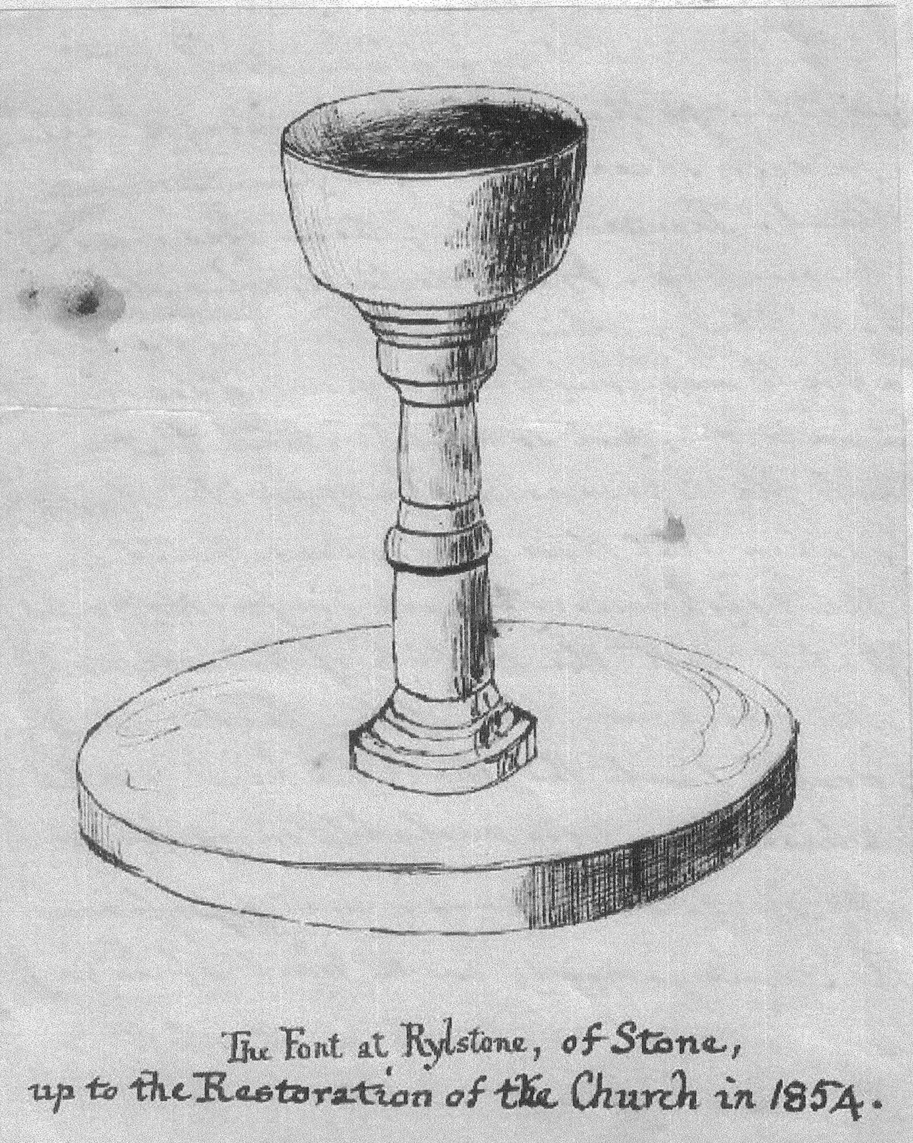

Bell Foundry Whitechapel London
Revd W Berry
for Rylstone Church

To Chas. & Geo. Mears

1853 cwt qr lb
Feb.1 Charges on Old Bells 2. 1. 8
June 1 A Church Bell 7 – 2 – 20
A -do- 6 – 1 – 1
A -do- 5 – 1 – 17
Cwt 19 – 1 –10 @£6.13.4 130.17. 3

3 Clappers, 3 Stocks, Wheels, Ironwork)
Brasses & Rollers ) 20.10. 0
Wharfage etc 8.10
153.17. 9

Cr. By 3 Old Bells 4.3.7
6.2.11
8.1.21 19 – 3 – 11
deduct iron staples & waste 26
Cwt 19 – 2 – 13@£4.13.4 91.10.10

£62. 6.11

Registers of Rylstone
The first is on Parchment & in good preservation. It comprises
the years 1559 to 1653.
The first entry is the Baptism of Robert, the son of Christopher
Proctor; and in the same year occur the names of Frankland,
Blackburn, Tenant, Kid, James Kitchen, Ellison. In 1560
Airton, Somerscalles, Carelil, Morvil, Cockson 1563, Stockdale,
Ibotson 1567,Garforth, Rathmel, Horner, Waynsman 1569.

A specimen of the way in which they were kept.
Burials 1566
No.8 A poor woman Jul.21
9 Jennet a poor maide Feb.15
10 Airton wife Feb. 20
Burials 1567
23 Olde Hill’s wife of hat. Feb.26

In 1599. 24 Baptims 8 Weddings 13 Burials
1602. John Toppam born at Cracoe, Deacon & Bachelor of Art
being of the age of 20. April 22 Curate of Rylstone from this year until 1661, 59 years, and aged 79.

The first Reading was on Wednesday March 14th 1866
P E N N Y R E A D I N G S.

The public are respectfully informed that in a
SECOND SOCIAL ENTERTAINMENT
CONSISTING OF
R E A D I N G S ,
INTERSPERSED WITH MUSIC AND SINGING,
WILL BE HELD
On WEDNESDAY, Evening, MARCH 28th 1866,
IN THE
NATIONAL SCHOOL-ROOM, CRACOE

The Chair will be taken by the
R E V. W I L L I A M B U R Y,
Of Chapel House, Kilnsey

P R O G R A M M E
GLEE–Fair Flora…………………..Messrs. Summerskill, Throup & Airton.
READING–Eccentric Sermon on the word “Malt” (Dr. Dodd) .................Mr. Hammond.
SONG–Paddle your own canoe………………………………….….…...Mr. Throup.
READING–Acts and consequences (Smiles)……………………….....Mr. A. Birkbeck.
DUET–Lover’s quarrels…………………….………….. ..Mr..and Miss Hammond.
READING–Where there’s a will there’s a way (Eliza Cook)…………Mr. T..J.Birkbeck.
SONG–O, would I were bird……………………………………….……..…Mr. Ayrton.
READING–Man was made to mourn (Burns)……………………………….…..Mr. Kidd.
SONG–Thinking of home……………………………………………....Mr. Etherington.
GLEE–The Owl………………………………………………….Hammond
READING–The mother and her dead child…………………………..…..Miss Hammond.
SONG–The White Squall……………………………………..…..Mr.J.S.Procter.
READING–The headstone (John Wilson)…………………………. Mr.J.S.Procter.
DUET–All’s well…………………………………….Messrs.Jaques and Ayrton.
READING–Simon the Quaker………………………………………Mr.B.Whalley.
FINALE–NATIONAL ANTHEM

Pianist - - - - Mr. ROLLINSON, of Skipton

ADMISSION :–ONE PENNY, A few Reserved Seats at 3d.
DOORS open at SEVEN o’clock; to commence at Half-past.
~~~~~~~~~~~~~~~~~~~~~~~~~~~~~~~~~~~~~~~~~~~~~~~~~~~~~~~~~~~~~~~~~~
EDMONDSON AND CO., MACHINE PRINTERS, “PIONEER” OFFICE, SKIPTON.

Buckingham Palace
April 23 1888
Sir,
I beg to acknowledge the receipt
of your letter of the 12th inst.
The Queen has occasionally
made a small donation
under the circumstances
you mention to persons in
distressed circumstances.
You do not in your letter
inform me when this event
took place, and whether
the three children are still
alive - unless the parents
are in distress, it would not
I think, be conferring a
benefit upon them to
teach them to look to
……?………assistance.
I shall be much obliged
to you if you will give
the information upon these
points.
I have the honour to be,
Sir
Your obedient & humble servant
CB Phipps

In the Rylstone Register under the year
1615 is the following letter, in the same
handwriting as the entries, evidently J.W. Topham’s

Good Mr Topham,
I desire you to take a script forth of your
Church Register of the burial of Thomas Walker
late of Cracoe deceased, and also of the christening
of William Snell who is now his haire; and
you must set your hand to the note, and your
Clerk also, that this bearer may safely sweare
it to be a true coppy. It concerns the King’s
service very much, and therefore I pray you
do not fail herein. Oct. 17. 1614, your
very loving friend Edward Radcliffe.
To my loving friend W. John Topham
Curate at Ril. this.

Also
Rilston 19th April 1641
Anne Paley hath certified the performance of
her declaration for fornication under the
Minister and Churchwardens hands and
is dismissed. William Paler
Also 1733
Mary daut. of Sam^{ll} Winsor. Begott upon y^{e}
Body of Margt. Kirk in a Dultry Baptiz’d
by Mr Craggs Jan 20.

Mr William Craggs was Curate of Rylstone.

I have already hinted at the bad neighbourhood which
subsisited between the Nortons and their superior lords.
Richard Norton, in particular, seems to have been a
turbulent man, violently addicted to the old religion;
while the Cliffords were dutiful subjects, and favourers
of the Reformation. On this account it is probable that
they beheld the ruin of their unquiet vassal with little
compassion. Yet it was long before the Cliffords, with all
their interest at court, could profit by this circumstance.
The Nortons’ lands in the centre of their barony, and the
object of long contentions, must have been a most desirable
object; yet neither the merits and gallantry of Earl
George, nor his just claims upon Queen Elizabeth, could
ever obtain from her tenacious hand what the complaisance
and assiduity of Earl Francis accomplished soon
after from her easy successor.
Rilston Fell yet exhibits a monument of the old
warfare between the Nortons and Cliffords. On a point
of very high ground, commanding an immense prospect
and protected by two deep ravines, are the remains of
a square tower, expressly said by Dodsworth to have
been built by Richard Norton. The walls are of strong
groutwork, about four feet thick. It seems to have been
three stories high. Breaches have been industriously
made in all the sides, almost to the ground, to render
it untenable. The Keepers of the Earls of Cumberland
complained against Norton Yorkies contrivance to

cont’d
impound the deer; and it is curious enough that
after almost three centuries, vestiges of this work should
yet remain. On the plain summit of the hill are the
foundations of a strong wall stretching from the SW
to the NE corner of the tower; and to the edge of a very
deep glen. From this glen a ditch, several hundred yards
long, runs S to another deep and rugged ravine. On the
N and W, where the banks are very steep, no wall, nor
mound is discoverable, paling being the only fence which
would stand on such ground. And this is the pound com-
plained of. From the Minstrelsy of the Scottish Border Vol.
1.p4 it appears that such pounds for deer, sheep &c were
far from being uncommon in the South of Scotland. The
principle of them was something like that of a wire mouse-
trap. On the declivity of a steep hill, the bottom and
sides of which were fenced so as to be impassable, a
wall was constructed nearly level with the surface and
the outsides yet so high within that without wings it
was impossible to escape in the opposite direction. Care
was probably taken that these inclosures should contain
better feed than the neighbouring parks or forests and
whoever is acquainted with the habits of these sequa-
cious animals, will easily conceive that if the leader
was once tempted to descend into the snare, a herd would
follow to recover which there were probably more frays
than lawsuits. After Rylstone came into possession of the
Cliffords, the same ground, with part of the fell above, was in-
closed for a park, of which it still retains the name and
the name only.

A Directory of the Township of Rylstone 1st July 1861
Blake – Captain Henry
Chamberlain Mrs
Crane – Rev. William M.A. Rylstone House
Maud - Abraham Esq Fleets House

Aldersley Anthony Farmer – Fleets
Ayrton John Farmer
Beckwith James Farmer
Carr Ann Farmer
Carr Robert Farmer
Dugdill Matthew Farmer
Pickering Adam Farmer – Sun Hill
Press Mary Postmistress
Robinson Robert Farmer – Moorside
Throup John Farmer
Wright Thomas Builder

______________________________________________________

_________________________________

Among the Shrewsbury papers in the Heralds’ College,
Dr Whitaker found the following Letter from the
Privy Council in the latter end of Henry Vlll.’s reign
on the subject of this dispute. “After commen-
dations &c.- Whereas complaynt hath lately byn
made to the Quenes Highness (Catherine Parr) that my
Lorde of Cumberlande, p’tending right of forest w’thin
certayne grounds belonging to John Norton wher ye
sayd Norton dothe clayme Free Warren, hathe now
of late not onlie intruded ther but causyd alsoe
sundrie of his s’vants to cast downe ye hedges and
dykes, &c. “This shal bee to advertize yow that ye
Quenes Graces pleasure is that yo’ putting my s^{d}
Lord of Cumb’rlande in rem’brance what unmet a
tyme this is for th’ attempting of such thinges, the
Kinges Majestie beyng now owte of ye realme, you
shal w^{th} good delyberation,as yow may, tak such
ordre yn this matt^{r}, as to reason and good equitie shall
ap’tayne: and if you shall not tak anie final ordre,
yet staying yn such sorte as ye pece and good quyet of
ye contre bee by neyth^{r} of you impeached. And thus we
byd y ^{r} good L’p most heartelee fare wel.

From Westm^{r} on this xix day of July 1544.

“T CANTUARIEN. TH. WROTHESLEY, Canc. E.HERTFORD.
TH. WESTM. W.PETRE.

“To o^{r} very good Lord Therle
of Shrewsburie, the Kinges Majesties
Lieut’ general in ye Northe.”

This is the only notice which appears in the evidences
at Bolton Abbey, relating to the insurrection of 1569,
so fatal to the Norton Family. Their ruin, in consequence
of this unfortunate engagement, is generally understood
from the old Ballad, entitled “The Rising in the North”,
where it said,
“Thee, Norton, with thine eight good sons,
They doomed to dye, alas! for ruth!”
Camden, however, in his Annals, mentions only three:
viz. Christopher, Marmaduke and Thomas; but in the
Townley M.S.S. is a distinct enumeration of 75 persons:
the ringleaders in this rebellion, who having fled,
were indicted, and many of these, probably attainted
in their absence. Among these appear the names of
Richard Norton, of Norton, Esq, Francis Norton of
Baldersby, Esq, Samuel Norton of Wath, Gentleman,
Christopher Norton, of Norton, Gentleman, Marmaduke
Norton, of Norton, Gentleman; Thomas Norton of
Skimmington, Gentleman. But whether Francis Norton
was the oldest son, whose aversion to engage in their
desperate adventure is stigmatised in the Ballad, and
whether all the remaining four were sons, or one of
them a collateral relative of the family, it is now im-
possible to discover. The only Craven names besides
in this catalogue are Robert Lambert of Caseton, Esq. and
William Malham of Elslack, Gentleman; neither of
whom seems to have been attainted, as there is no
evidence that their estates were forfeited―

Cont’d

the property of the Lord, which together with the wood, had
after the attainder of Mr. Norton, been committed to Sir Stephen
Tempest of Broughton. The latter, it seems, had been
abandoned to depredation, for, upon a survey, there appeared
the stumps of 86 oaks, 144 ashes, 217 elders, 99 hollies.
Of these the oaks were valued at one shilling each; the
ashes at four pence, the elders and hollies at one penny
each. Now, though we should be scarcely warranted in
supposing these to have been the heaviest timber upon
the estate, yet they must have been something more that
walkingsticks; and if the valuation of 1603 be multiplied
by ten, it will probably not equal the present value. But
the whole timber of the township was estimated in this
survey at £300, equal, according to the former ratio,
to be more than £3000, which, as it must have been confined
in a great measure, to the lower parts of the township,
leaves the impression of a very forest like & sylvan scene.
There was neither a freeholder nor cottager in the place:
the occupiers were properly speaking, tenants at will,
though the Lord granted them verbal leases for life. The
fines were entirely arbitrary, but no heriots were paid.
The tenement was usually granted, upon the demise of
a tenant, to the oldest son, if there was one; if not to the
oldest daughter. Among the old tenants is mentioned
one, “Richard Kitchen, Butler to Mr. Norton, who rose
in rebellion with his master and was executed at Ripon.”

On the 28th of December 1857, between the hours of 11 and 12
at night, Nancy (née Gregson) the wife of Andrew Stockdale
of Cracoe, in her 22nd year, was delivered of two Female
children, and on the 29th between 1 and 2 in the morning
of another Female child, all of which lived and were
baptised by me on the 29th by the names of Faith,
Hope and Charity. I afterwards wrote to the Queen about
them, in consequence of being told that she always made
a present to any Mother of three children at one birth,
and received from her, through Col. Phipps, the sum
of £Three Pounds. I afterwards discovered that there
were circumstances which would have prevented the receipt of this Bounty. Andrew Stockdale, aged 26, and Nancy
Formerly it was usual to send a present from the
Queen to any poor man’s wife who had three children at
a birth. The wife of a railway porter at Canterbury,
named Legg, a short time since had three children,and the
vicar of St.Dunstan’s sent a statement of the fact to the
proper quarter. Lasst week she received £6 from the
Queen.
Gregson were married at Burnsall only on the 31st of October, 1857, only 2 months before this birth.

Between the Village of Rylstone and Skipton, at the distance
of half a mile from the former and of a few hundred
yards from the highroad, there is an old House
called Scale House, which from its size and appearance must
at some period or other, have been a place of some import-
ance. On the walls of one of the Rooms on the ground floor
are Painted Panels, containing subjects relating to
Hunting and Agriculture. It belongs at present to a
Family of the name of Morley. Here is a slight sketch
of it, made when I lodged there from June to August 1839.

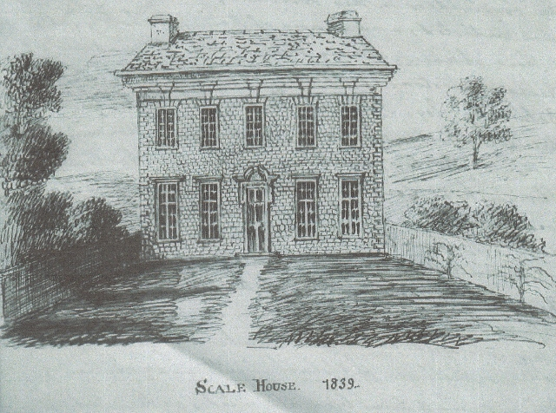

Hetton Oct 28th 1853
Dear Minister
I Reseaved your Letter on the 13th
Saying you would Call On J Carlisle On Monday
Or Sunday Next to have Sum Conversation with him
On the Subject about the Sittings as I understand
It I watid at home onMunday and Tusday and
then I herd you was Gon through Our Vilige On
Tusday and Not Call then I waitid your Return
On Wedensday Thursday and Friday and Saterday
I went to Skipton and I herd you Came through
but did not Call and Now hear is a Nother Week
Week Going on and you have not Called on Mee
if I had written to you on any Subject to Call at
Chapil House On Each of those Days I should
a been Verry Ankshas to Called Acording to Promis
if you had Given Mee Any Ofence I should a writon
to Letten you A known My Reason for Not Calling
So you have Neither Called Nor Written
You wished Mee in Your last note to Ocupy
Mrs Johnsons Pew On the fowling Sunday which
I did not Acording to your wish I made Mention
it to Mrs Johnson On Saterday Night and She Seems
Not Suted So if I Canot have my first alotment and
Nearly the Old Ground that had belonged to My
Property I Shall keep away from the house of God
as you Call it it Seemes all your Rich Parisers
is Put in the East West North and South Corner
Acording to thear Desires and they think they
Can Put Such as Mee aney Whear Whear is it
Said when the Rich Man and Lazeras Died
Went two did he Chuse his Plase because he
was A Rich Man they Chuse thear Own
Plases in Rilston Church and Mine two
dose My Rich Neighbrs but I hope they will
be bet in Another World for Chousing Mine
Yours Well Wishes J Carlisle

At this time a white Doe, say the aged people of the neigh-
bourhood, long continued to make a weekly pilgrimage from
hence over the fells to Bolton, and was constantly found in
the Abbey Church Yard during divine service; after the
close of which she returned home as regularly as the rest of
the congregation.― This incident awakens the fancy.
Shall we say that the soul of one of the Nortons had taken
up its abode in that animal, and was condemned to do
penance for his transgressions against “the lord’s deere“.
among their ashes? But for such a spirit the Wild Stag
would have been a fitter vehicle. Had the milk white
Doe performed her mysterious pilgrimage from Etterick
Forest to the precincts of Dryburgh or Melrose, the ele-
gant and ingenious Editor of the Border Minstrelsy
would have wrought it into a beautiful story.

Norton Tower was, however, probably a sort of
pleasure-house in Summer, as there are adjoining to it
several large mounds,(two of them are tolerably entire)
of which no other account can be given than that they
were Butts for large companies of Archers. The place
is savagely wild and the situation admirably adapted
to the use of a watch tower. Adjoining to the Manor
House is a Chapel, resembling a Parish Church, with a
Tower, Choir and side Ailes. The original structure
has been at least as ancient as the reign of Stephen;
for the Buttresses at the east end of the middle choir
exactly resemble those of Burnsall, and the font

cont’d

is cylindrical. It was probably a foundation of one of the
earlier Rylstones. But the side ailes, with the Tower, can
claim no higher antiquity than the earlier part of Henry the
Eighth’s reign and are probably the work of John Norton
who married the heiress of Radcliff. Of this there are two
proofs: first on one of the pillars of the South aile is a
shield, of which the dexter pale undoubtedly charged
with the arms of Norton, is hid behind the pulpit:
the sinister is composed in a very singular manner of
Radcliff and Rilstone, as it consists of a bend engrailed
sable for Radcliffe between two Saltires: for Rilstone bore
A. a Saltire S, which out of much painted glass remain-
ing within my memory in the Chapel, has alone escaped
a late sweeping repair. The South Chantry belongs to
Rylstone Hall, but has no memorials of the families inter-
red within it. That on the North is appropriated to
Bordley Hall.
Secondly, on one of the Bells, which seems coeval with
the building of the Tower, is this cipherJ.N for John
Norton; and the motto,God us ayd.
Here was an endowed Chantry# certified by Archbishop Holgate to
be of the foundation of Jeffrey Proctor and the value of
£4. 4s. The Proctors were of Bordley; for which reason
I suppose our Lady’s altar to have been in the North
Chantry.
The two Chapels of Rylstone and Conistone have no
Chaplains, nor separate endowment; but they are (some missing)

# Chantreys were Colleges of Priests, retained to say
Masses and Prayers for the souls of the Founders of their
families. They continued to multiply until 1st Ed. VI. when they were suppressed & their endowments confiscated, in number 2374. See
Massingberds English Reformation, page 62 for an account of them
Can’t find it on this page)

Mr.Alcock
He was once performing the ceremony at a
Marriage, where the lady objected to repeat the
word “obey”. So he said, “Well, my dear, it is
an awkward word; skip on to the next.”
He was once preaching one Sunday morning
in the Church at Kirkby Malham, when he was
observed to burst into a fit of laughter. The
congregation wondered what could have caused
such behaviour, when W. Alcock thus explained
himself; “You all know John……..” (here he
named a very and eccentric Farmer); “well,
as he was crossing the Churchyard just now, he was
upset by an old sow getting between his legs,
and the sight of that was more than my gravity
could stand”. This explanation put the whole
Church into a roar. When peace was restored,
Mr. Alcock said very coolly, “Now, who’ll
be the first to tell the Bishop?”
Once when Mr. Alcock was on his way
to the afternoon service at Rylstone, he espied
a lot of boys in a field, playing at Foot Ball.
Mr. Alcock went up to them and said,”This is
very wrong; you are breaking the Sabbath”
But the remonstrance failed to produce any
effect, and so he stood looking on and shaking
his stick, until at last the Ball chanced to
roll close to his feet, upon which he gave it a
grand kick, and sent it flying so high and so
far, as to draw down a shout of universal
applause. “That’s the way, my lads”, he said,
“to play at football!” With such an example
it may be supposed that the boys did not dis
continue their sport, but on the contrary
boasted far and wide that their Parson had
joined in the game!

Chapel House is a modern erection (about 1783) standing on the
side of the Hill which forms the right boundary of the Valley
of the Wharfe at the distance of about half a mile to the
South of Kilnsey. It commands a beautiful view of the
River, Grassington Wood, Netherside and the Fells above
Cracoe and Rylstone. It is said to be haunted by the
Ghost of one of the Tennant family, who is still remembered
in the neighbourhood as “Lawyer Tennant” and is said
to have been a rough passionate man, and an awful
swearer. He has been heard to swear all the way from the
House to Conistone. On the night when he died there
was a dreadful storm: his pack of hounds got loose from the
kennel below the House, & coming up at full speed
set up a dismal howling. An occupier of Chapel House, a
Mr. Bolton is said to have seen the Ghost on the stairs and
to have fired a pistol at it. An Auctioneer from Skipton of
the name of Merryweather once slept at Chapel House. He
declared in the morning that the figure of a female glided into
his room in the middle of the night and drew the clothes off
him. He added that he would not spend another night in the house for all Mr.Tennant’s estates there.

Anecdotes of some of my Predecessors
Mr. Withnell
Sept 1841
In a conversation which I have had with Mrs. Bland, she
told me that Mr. Withnell was so illused by his Parishioners
in the matter of Tythe, that he never was able to have a decent
coat on his back,and frequently none at all. On one occasion
he came down to Mrs. Bland’s Aunt, who kept a small shop,
on Sunday morning, and purchased a pair of stockings,
a neckcloth and a shirt to make his appearance
in the Pulpit. Her Aunt never got paid for them.
______________

Mr. Alcock
It is said that when the same individual who unstitched
his Sermon once dined with him on a Sunday, Mr. Alcock
invited him to stay the afternoon Service, but the man
begged to be excused as the days were short and he should
be benighted. “Nonsense!” said Mr Alcock; “I’ll give you
my word of honour that the Sermon shall be a very short
one.” His friend, thus assured, accompanied him to
Church; where sure enough, the Sermon was only
about a quarter of an hour long; but then came the climax,
for the Clerk called upon the Congregation to sing “the
whole of the 119th Psalm, beginning at the first verse!”

Mr. Alcock was a very immoral person. Besides keeping a
pack of Hounds and hunting regularly to the great neglect
of his Parish, he had also a Mistress. On hunting days
his huntsman used to bring this woman behind him
on horseback to the place of meeting. He had several
children. One of them is at present (May 1840) living at
Burnsall & is in her 83rd year. She lately walked over to
Linton to try to beg something of me. On conversing with
her she informed me that she also had had a natural
child, a Daughter, by a Doctor Jaques of Grassington
and had altogether lived a very disreputable life.
A sister of hers, who lives at Leeds and is, I believe
the landlady of the Bull and Mouth Inn, allows her
three shillings a week, and upon this the poor
creature contrives not only to live, but even to save.
As soon as she has scraped together enough to pay
her travelling expenses, she goes to see her natural D^{r}.,
who is a Widow in comfortable circumstances & lives near
Slaidburn. They cannot however agree together long,
and it always ends in a quarrel: the daughter beats
her Mother, who then returns home & commences starving
and saving afresh, for another journey.

Mr. Tennant of Chapel House was much addicted
to swearing and seldom came to Church. One day,

contd.

Mr Alcock had begun the service and had already got
a good way through it, when Mr. Tennant came in.
Upon this he cried out to the Clerk “ Eh! James, here’s
the Squire coming! he’s so seldom here we had
better begin again and let him have
it all.” And accordingly he began again &
read over a second time the part that he had
already got through, when Mr Tennant arrived.
Mr A. used frequently to have to bathe his
burning brow in the trough under the spring on the
green at Rylstone, and to try to wash himself
quite sober, before he went up to Church.
And it was a constant amusement with
the boys at Cracoe to lay hold of his Pony’s tail
as he returned from Church on a Sunday and to
hunt him round the green until his hat and
wig fell off.
Upon one occasion, observing a man fast asleep
just under the Pulpit, he paused for a few seconds
and then added: “Well since you will not hear
the Word of the Lord, you shall at any rate feel it”
and so saying dropped his Pocket Bible upon the sleeper.

Mr Alcock’s wife has been described to me as a lady of good
family from the neighbourhood of Ripon, a very nice, pleasant
and clean person; while the woman from Hebden, with whom
he lived, was the contrary, a low, plain, “mucky & offal” sort
of woman. He had one child, a son, by the former; many, both
sons and daughters, by the latter. During the early part of his con-
nection with her, & when it was more suspected than actually
known, a rumour one day flew about Burnsall, where he then
lived in the School House, that she had come over from Hebden
& was somewhere concealed in the house. Some young men
determined to search for her & put the matter to the proof.
Accordingly they searched the School House from head to
foot and more than once, but all in vain; nothing could
be found. As they left the building and were about to
return, re infectâ, one of them said, “ Shor connot be
there; for I’m darned if we’ve not searched every spot
i’t pleeas, ‘xcept th’ Clock.” “An’ by Gord,” said another
of the company, “we’ll hav a spell at it, afore we go”. And
so they turned back, & on opening the ClockCase, found the
Lady standing up in it.

Told to me by Edmund Brown of Cracoe,
in his 87th year, 24th Feb^{y}. 1864.

Miscellaneous Collections from various sources

(1)In the time of Henry VI, on one of the spungy flats now drained
and inclosed on the road leading to Rylstone, there was a Pool
called “Alanwatter Tarn.” See Saxton’s Map of Yorkshire. It
was in the Township of Skipton.

2) A Tower, called Clilfford’s Tower, formerly stood on the confines of
Embsay and Crookrise.

3) Wolves, though rare, were not extinct in Craven in the begining of
the 14th Century. There is a payment in the Compotus of Bolton Abbey
for the year 1306 ‘cuidance qui secidit lupum’ and again for
1307.

4 )In Hen.VIII’s time, ‘every Bride coming by the way of Crookrise
was to give either her left shoe or 3s.4d to the Forester of
Crookrise by way of custome’.

5)The Father of the present Richard York Esq. of Wighill Park was called Whittle Sheepshanks. He was a very shrewd and good man, and
amassed a considerable property. It is said that he once purchased
some sheep of a Scotchman at one of the Skipton cattle fairs and not
having cash enough with him to pay for them, he said to the man,
“I’ve no money by me at present, but I’ll settle with you next fair.” “An’ who may ye be, Sir?” said the Scotchman. “What, don’t you know me!”
I thought everybody knew Whittle Sheepshanks.” “Hout mon!”
said the Scotchman, “dinna think to make a fule o’me; wha ‘ever
heard sic a name o’a sheepshanks wi’ a whittle to it!” This
so offended Mr Sheepshanks, that he changed his name to York.

6)The inhabitants of Cowling are called “Moons”, in derision, from
the following circumstance: A Cowling Shepherd once went to
Skipton late in the evening, and when he entered the town the
moon was shining brightly. He is said to have made the fol-
lowing wise remark: “How like your Skipton Moon is to ours
at Cowling Head”.

Cont’d

7) On the side of Primrose Hill in Lothersdale there is a field
called Swine Harry. It is said to have derived its name
from the following singular circumstance. A man
who had stolen a Pig from a neighbouring Farmer, and
crossing this Field at midnight, with his prize which
he led by a rope fastened to its leg. He was very fat
fellow, and on coming to a ladderstyle in the field, he was
anxious to have both hands at liberty to help himself over.
He accordingly slipped the loop which he had been hither-
to holding in his hands, round his neck, and in this
way mounted the style; but as he reached the topmost
step his feet slipped and he fell forwards head first.
The pig was on the other side, the loop tightened and
he was strangled. On the following morning he was
found dead.

8) A little time before the general Election in 1841, when Lords
Morpeth and Milton were contesting the West Riding
against Wortley and Denison, an old woman living
at Grassington was heard to say that “she hoped that
the Conservative party would not succeed, because if they
did, she reckoned Mr. Bury would get his Tenths: and
it would be very hard that he should have every tenth child
because poor folks were just as fond of their children
as the Quality were.” This anecdote was told
me by the Rev. Mr. Fearon of Grassington.

9) One of the Tempests is said to have leaped on Horseback across
Gordale

Cont’d

(10) When Sir Humphrey Davy was at Gisburn, the late Lord
Ribblesdale took him to see the celebrated Gordale Rocks,
expecting that they would astonish and interest him, and
call forth some very learned remarks; but the great Phi-
losopher noticed only the stream beneath them, which he
scrutinised minutely, saying he was sure there were no
fish in it, or he should have discovered them.

(11) Some years ago Dr. Whitaker and the Rev. William Carr of Bolton
Abbey obtained permission from the Earl of Thanet to open the Tomb
of George, third Earl of Cumberland, which is in the Parish Church
at Skipton. They found the Body in an extraordinarily good state
of preservation. The hair, which was very long, was of a reddish colour
and rather coarse. The features were marked: the nose high and
aquiline: the skin was of the colour of light Mahogany. So well in-
deed were the features preserved, that when, a few weeks after-
wards Mr. Carr was being conducted round the Public Library
at Oxford, along with a large party of Strangers, he recognised
his Portrait at once; and upon being told by the
Cicerone that he was right in his conjecture, he added, “I
was sure that I was, because I saw him a few weeks ago.”
This, of course, rather startled the party, and it was very
Evident that they thought him either out of his mind or a
most egregious Liar, but, when after persisting in the Joke
for a little longer, ne at length explained the whole circumstance,
they were delighted with him and he immediately
………..rest missing

Mr.Bury Hetton Sept.24th ‘59
Sir I Was informed by Tho.s Dugdil Our Church Warden that you and your Cumitty had Put Thos. Kidd House and Edward Longbottom House to Mine that I live in We are Eight of family at Present. Expects another Every Day. Thos. Kidds is Seven of family under thear Roof. Edward Longbottom is four of family all in number makes 19. You as A Rilston Minister I hope you will Consider we have Each Soules to save. Now I will turn to Missis Chamberlain She is her Self, her Daughter and two Servants has a Pew alotid for her Siting for Twelve to her house with out any land to it Now I turn to Myself again I have a good house Twenty akers of Land to it Best Property in the Village all to Gather Now as I am Informed is only allotid as a Cotiger in your Church I consider it is Misis Chamberlane that you ought to alot as a Cotager without Land Not Mine with Land to it.
Now I turn to Kitching of Craco he is Getting On Long Pew and on Shorton to An house to hiSelf. If you as a Christan Minister think this Right that Is used with Other People I do Not to My Situation that I ocupay, If you think that Rich Peoples Soules want More Roome that Poor Peoples to worship God I do Not. If your Churchwardens and Cumitty was Persons of Religon instead of Profesors they would A Put Thos. Kidd to Kitching Longboton to Birnecks and Two to Mistres Chamberlane and only One to Mee that you call Cotager if you do so I shall be Satisfied.
Your Well Wishes
Johnson Carlisle

