Norton Tower
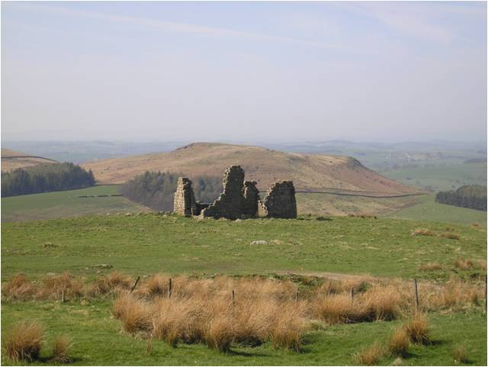 photograph L Primmer

This article looks at some of the publications and archaeological investigations discussing Norton Tower its origin and uses.
The Tower is a well known monument to the south of the village seen [high on the edge of the moor if looking right when travelling north], on the road from Skipton to Grassington. There are several theories as to its purpose. These include : a Pele Tower (a small fortified keep or tower house, of which several were built near the Scottish borders , intended as watch towers where signal fires could be lit by the garrison to warn of approaching danger from over the border raids);
a watch tower to stop the Cliffords stealing the deer from the Nortons;
a hunting or banqueting lodge with archery butts or jousting to amuse Richard Norton’s large family;
a warren lodge (accommodation for the warrener and a place to keep carcasses and skins , as well as all the nets, traps and necessary equipment) in association with the pillow mounds of the artificial rabbit warren..
Whittaker in his book “A History of Craven” first published in 1805, third edition 1878 ^{1,} brought to the notice of the general public a series of ancient or fairly old works and gave a certain amount of fact and theory to account for them. Not long afterwards in 1815 William Wordsworth used these observations for imaginative purposes in a poem The White Doe².
“Wordsworth’s poem is a long, romantic narrative about the Rising in the North, concentrating on the tradition of the phantom white doe which appeared to comfort the grieving Emily, lover of Francis Norton, the son of Richard. Norton Tower is mentioned several times in the narrative, as their favourite place of resort:
‘High on a point of rugged ground
Among the wastes of Rylstone Fell
Above the loftiest ridge or mound
Where foresters or shepherds dwell,
An edifice of warlike frame
Stands single--Norton Tower its name--
It fronts all quarters, and looks round
O'er path and road, and plain and dell,
Dark moor, and gleam of pool and stream,
Upon a prospect without bound’.
The poem also describes
‘the sound of glee when there the youthful Nortons met,
To practise games and archery’:

This idea has its origins in identification (certainly spurious) of the pillow mounds near the Tower as archery butts.”
Whittaker thought the tower was built about 1540
The following extract from Whittaker’s book¹ probably inspired Wordsworth
“Rilston fell yet exhibits a monument to the old warfare between the Nortons and the Cliffords. On a point of very high ground, commanding an immense prospect, and protected by two deep ravines are the remains of a square tower, said by Dodsworth³ to have been built by Richard Norton. The walls are of strong grout work about four feet thick. It seems to have been three stories high. Breaches have been industriously made in all sides almost to the ground, to render it untenable.”
Whittaker goes on to assert that this destruction is the work of Earl of Cumberland’s (Clifford) keepers against Norton because of the latter’s contrivance to impound deer.
“On the plain summit of the hill are the foundations of a strong wall, stretching from the SW to the NE corner of the tower, and to the edge of a very deep glen, from this glen a ditch, several hundred yards long runs to another deep and rugged ravine on the N and the W, where the banks are steep no wall is discoverable paling being the only fence which would stand on such ground. This is the deer pound.”
Whittaker (P526) further states that Norton Tower seems also to have been a sort of pleasure-house in the summer as there are adjoining to it several large mounds ( two of them pretty entire) , of which no account can be given other than that they were butts for a large company of archers. The place is savagely wild and the situation admirably adapted to the use of a watch-tower.”
Hence Whittaker has two explanations for Norton’s Tower: watch tower against the Cliffords and / or a pleasure house with archery butts.
Norton Tower’s entry in the Historical Environment Record (HER)⁴ reads,
”The ruins of Norton Tower stand on the strongest point of a natural ridge, and are flanked on the east side by a slight bank and ditch. The Tower was probably built by Richard Norton of Rylstone Hall around 1540. Legend has it that it was used to house watchers after a dispute with the Cliffords of Skipton Castle over hunting rights in Rylstone. It is more likely to have been a guard post for the associated rabbit warren. It may also have been used by its aristocratic owners for banqueting when they were out hunting. The bank and ditch may have formed part of a palisaded enclosure, later walled, that covered the summit of the ridge and was primarily designed for herding deer. The Tower measures 9.5 by 7.5 metres with walls 1.2 metres thick, standing to a maximum height of 5 metres.”
Thus the HER covers three possible uses for the tower.
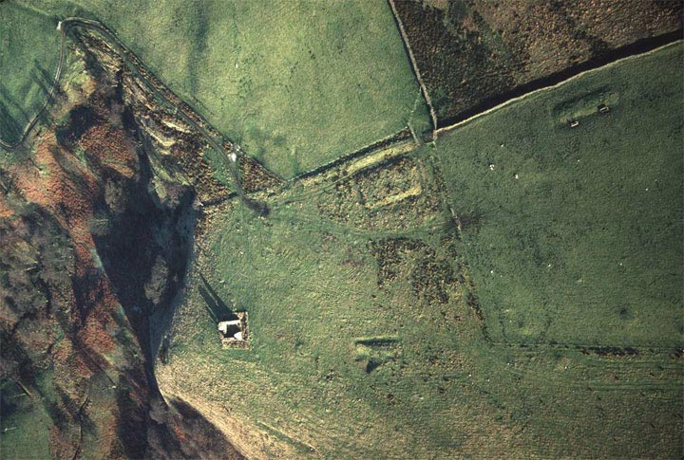

Aerial view of Norton Tower from the HER
The tower is in the centre of the photograph there are signs of the foundations of two other buildings and one standing building can also be seen.
Norton Tower is a grade II listed building. It was listed in 1969 and the “ listing description” reads:⁵
“Remains of tower. Probably C16 built for Richard Norton of coursed gritstone. A square structure, approximately 10 metres x 15 metres, the corners standing approximately 3 metres high but the walls slighted. Original entrance probably on the south side, remains of a fireplace and stone newel
stair on east side, no windows survive. The ruin stands among extensive earthworks and is only one part of an important archaeological site which includes rabbit warrens (pillow mounds) and probably prehistoric field clearance cairns to the south. The building was a hunting lodge of the Nortons of Rylstone and Norton Conyers and was slighted after the family's involvement in the Rising of the North, 1569.”
So according to the listing it was a hunting lodge for the Nortons
In 1915 F. Villy excavated the site and wrote it up for The Bradford Antiquaries^{6.} He quotes (P182) a
Mr WM I’Anson saying , “ that as far as he can judge from the photographs it was a Pele tower.”
Villy’s conclusion was that it was “clearly a dwelling place designed for strength, and although it would not stand a serious siege it would be a very suitable shelter for a band of watchers over the Norton interests.” Further he considers that the walls and banks around it could have been used for herding deer.
Villy excavated two long mounds close by and thought they were early mediaeval, though he did not discuss what their use might have been. He also opened four further mounds, each of which contained a pit. He thought “these mounds were barrows.” The pits were large enough to contain a contracted body. In such acid soil a body simply inhumed is known to disappear completely over the centuries, and burial without grave furniture was the rule. He did find charcoal in these mounds.
Figure One from Villy’s paper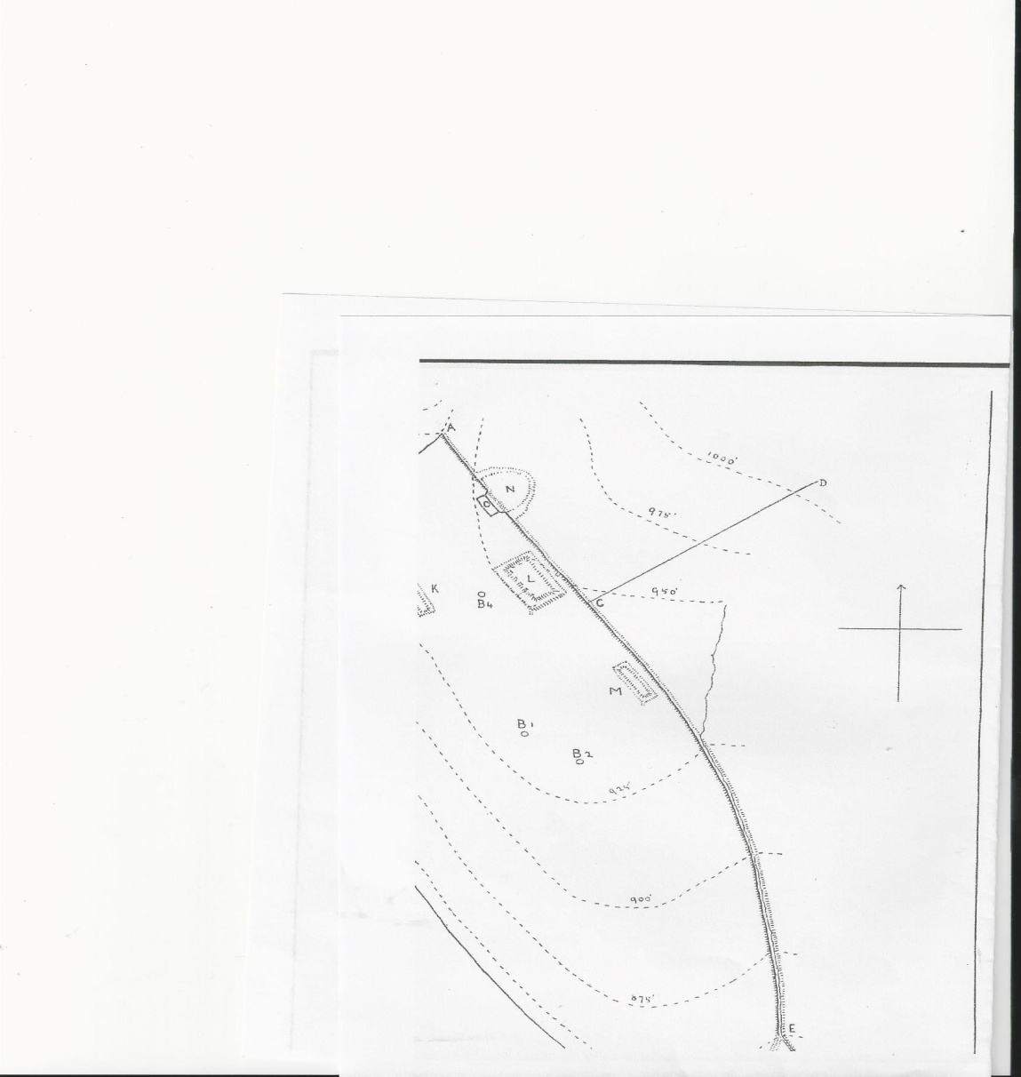
Key
L and M =Large mounds
B1, B2, B3 and B4 = Four barrows

There is a note from Arthur Raistrick⁹ in which he describes excavating a bloomery by Norton Tower in April 1967 and from his note he thinks there was lead smelting as well as iron workings. He found charcoal – fragments, some oak, some possibly beech. He also recorded a clay hearth – of whitish-grey fire-clay, probably from Rilston Fell, contrasting with the underlying red clay. Both clays had been baked hard. He found no stone structure surviving.
He dated the bloomery to 1150 - 1650 A.D. ” There is no way of knowing where this was in the vicinity of Norton Tower but charcoal had been found by Villy in layers in the pillow mounds.

Steve Moorhouse did some work at Norton Tower in 1991 financed by English Heritage⁷. His fieldwork suggests “that the tower and attached wall surrounding an extensive enclosure to the South are of more than one phase and the site is a late mediaeval defended rabbit warren and hunting enclosure.” He comments that the plan produced by Villy⁶ is largely accurate “but he omits the many cairn like rabbit burrows on the top of the hill and down the hill slope within the enclosure. Excavation by Villy of two of these cairns produced results which prompted later speculation by Raistrick⁸ ⁹ that they were for jousting games or horsemanship, but are now better interpreted as one of the many ways in which mediaeval and later warreners attracted rabbits to stay in one place. A multi-phase terrace way leads from the tower due Northwards, beneath the existing field boundaries, through the successive late mediaeval park towards the Norton’s Manor House at Rylstone. The tower and attached enclosure probably owe their origin to a dispute over hunting rights which led to an early 16th century court case over hunting rights between the Nortons and the Cliffords, who held much of the land to the East. Both families erected defended towers on high ground almost within sight of each other on , on their respective sides of Waterfall Gill Beck, the boundary of the property between the two families.
The latest report on Norton Tower was an Archaeological report by Brigantia Archaeological Practice for Mr J Caygill and the Yorkshire Dales National Park Authority ^{2.} It gives a very detailed description of the tower as it stands today but also some discussion on its probable purpose and historic setting as follows.
“It seems likely that the old wall to the south of the tower represents the boundary of the deer park which was established in the 17th century after the estate had been acquired by the Cliffords. This is suggested by the massive scale of the wall, and by the hollow which runs along its western edge and which can be seen as the remains of a ha-ha. If this is the case, the creation of the park may be seen as the formal enclosure of an existing hunting ground, in which the Tower played an important part. It is likely that it served as a guard-house for the hunting grounds which were, of course, the subject of considerable dispute- but it was perhaps equally important as a banqueting house, important in the complex and competitive protocols of hospitality involved in Tudor hunting.”

Interpretation of the landscape south of the Tower as a deer park is supported by the
presence of three pillow mounds. These are rectilinear features, in the form of a low, level
mounds, ditched on all sides. Their identification with artificial coney warrens is well established
and, in this case, is supported by an attested history of rabbit-breeding at Rylstone. They are not archery butts as had been suggested by Villy^{5.}

Scattered across the area to the south of the Tower is a cluster of ten distinct cairns, as well as two more possible cairns, one of which is badly disturbed. To ascribe a date or a function to these cairns is not straightforward. They are recorded in the Historic Environment Record as clearance cairns, and may well be no more than heaps of stones picked from the surface of a naturally stony field; indeed, there are occasional fresh-looking, piles of stones without vegetation present, in the general area suggesting that this practice continues today. It was not possible to identify all 30 of the small cairns of stones, which appear to have supported posts….(which) may have been for jousting games or horsemanship according to Raistrick⁸ and the idea that they supported posts is not supported by the surviving evidence.

Should these indeed have originated as clearance heaps, a prehistoric date is possible, but the
possibility that they relate to the preparation of land for the deer-park cannot be discounted.
It is also possible that at least some cairns represent prehistoric burial mounds; the site, on a false crest and intervisible with known burial mounds, is in some ways typical of an Early Bronze
Age cremation cemetery.Brigantia Archaeological Practice report 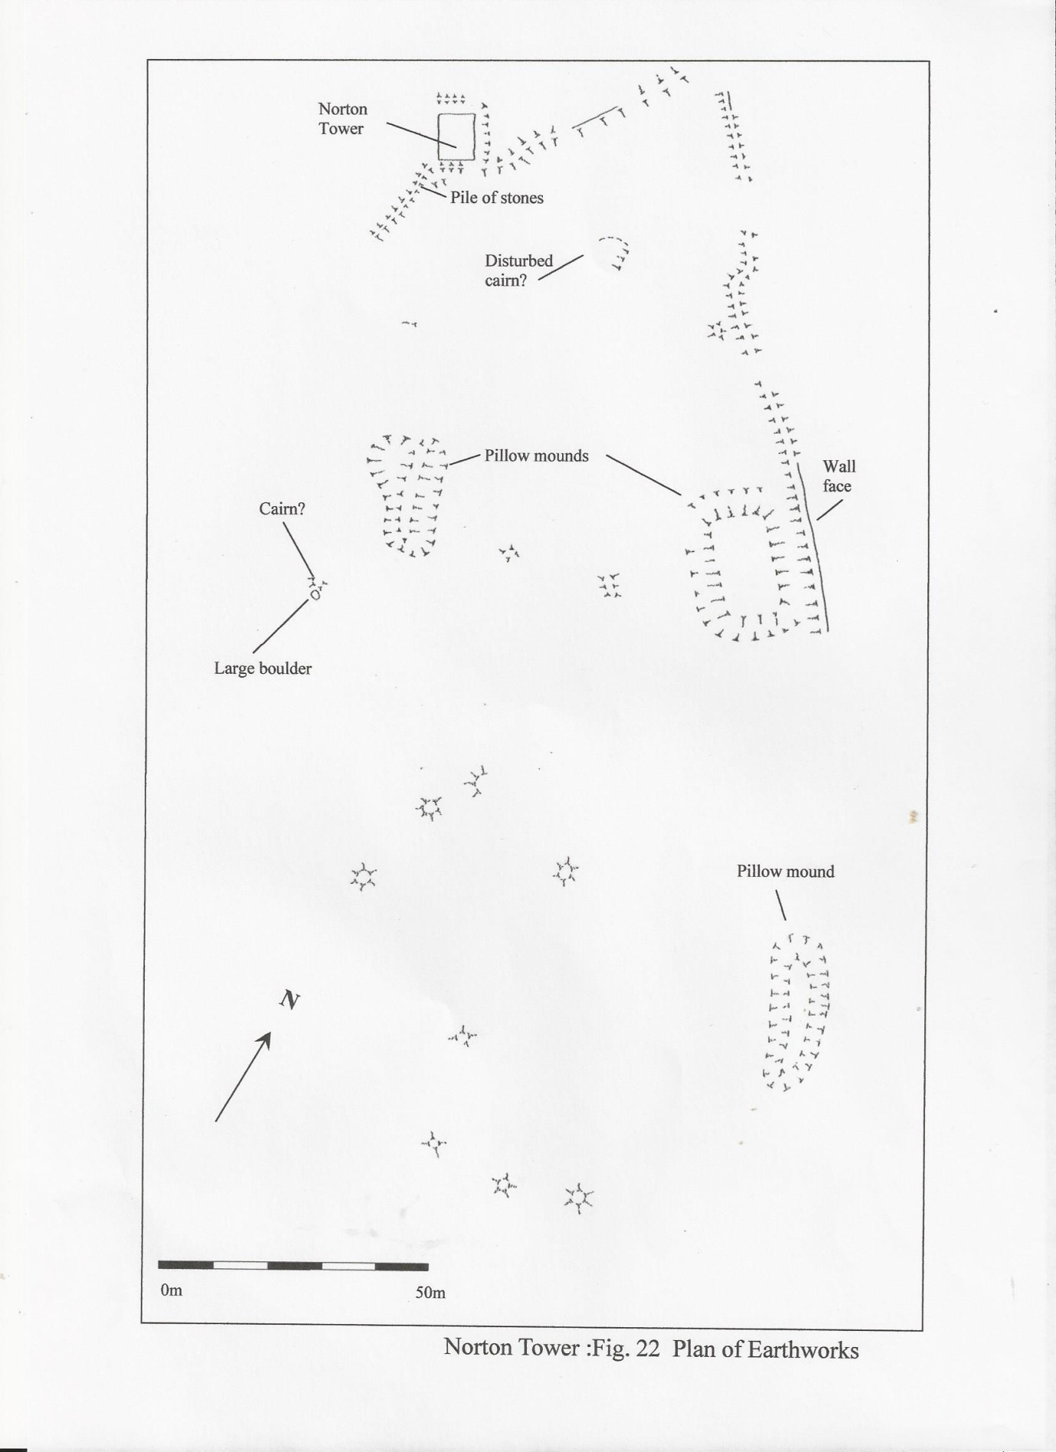

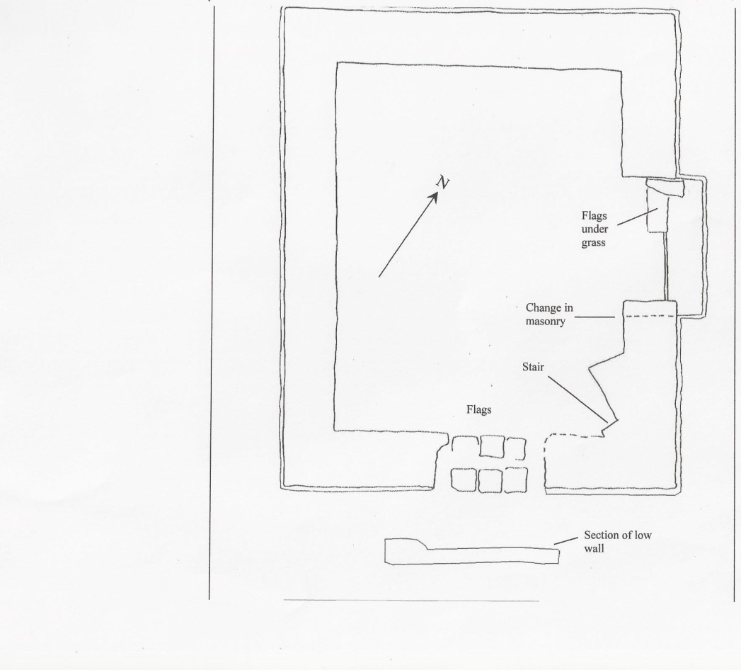
Plan of Norton Tower from Brigantia Archaeological Practice report

References
1.The History and Antiquities of the Deanery of Craven in the County of York - Norton lands P520 Rev. T D Whittaker first published 1878 republished 1973
First publication of third edition: Leeds: Joseph Dodgson; London: Cassell, Petter and Galpin.
Republication: Didsbury, Manchester: E.J.Morten and Skipton: The Craven Herald

2.Brigantia Archaeological Practice report. An Archaeological Survey of Norton Tower, Rylstone, Craven (Yorkshire Dales National Park)and associated landscape A report to Mr J. Caygill February 2012

3.Roger Dodsworth (1585–1654) was an English antiquary ( see footnote below) Preface to the First Edition by Whitaker Ref 4 Page ix refers to, 'In the same collection were transcripts of Dodsworth's to the Second Edition by Whitaker Ref Page xv refers to an acknowledgement to his friend - a Mr. Beaumont - for access to his papers and says that, 'no man living had taken the same pains with Dodsworth's MSS., or so well qualified to make an index to that confused but Valuable collection'.

4.Historical Environment Record for Norton Tower No: MYD3933
Parish: Rylstone OS Grid Reference: SD976570 Dale: Lower Wharfedale
archaeologydataservice.ac.uk/archives/view/420/

5.Norton Tower Grade11 listed building Listing NGR: SD9759257033
SE 95 NE B6265(east side, off) 6/69 Norton Tower 6.10.69 listing date

6.The Site of Norton Towers F Villy MD Bradford Antiquaries, The Journal of the Bradford Antiquarian Society October 1915
7.S. Moorhouse Newsletter of Council of British Archaeology group lV 1991C Norton Tower Rylstone mNorth Yorkshire CBA Forum 1991 Annual Newsletter p29
8.Raistrick, A., 1963, ‘Norton: A Former Jolly summer House’ in The Dalesman, 25, 629-631
9.Raistrick A. 1967 “ Old Yorkshire Dales” 1967. 38 David and Charles, Newton Abbot
10. Raistick A 1967 A personal communication from the late Richard Harland

Footnote on Roger Dodsworth
He was born at Newton Grange, Oswaldkirk, near Helmsley, Yorkshire, in the house of his maternal grandfather, Ralph Sandwith. He devoted himself early to antiquarian research, in which he was greatly assisted by the fact that his father, Matthew Dodsworth, was registrar of York Minster, and could give him access to the records preserved there. He married Holcroft Hesketh, the widow of Laurence Rawsthorne of Hutton Grange, Penwortham, Lancashire where he subsequently resided until his death in August 1654.
At various times in his life he was able to study the records in the library of Sir Robert Cotton, in Skipton Castle and in the Tower of London. He collected a vast store of materials for a history of Yorkshire, a Monasticon Anglicanum, and an English baronage. The second of these was published with considerable additions by Sir William Dugdale (2 vols., 1655 and 1661).
The manuscripts were left to Thomas Fairfax, 3rd Lord Fairfax of Cameron, who by his will bequeathed them (160 volumes in all) to the Bodleian Library at Oxford. Portions have been printed by the Yorkshire Archaeological Society (Dodsworth's Yorkshire Notes, 1884) and the Chetham Society (copies of Lancashire postmortem inquisitions, 1875–1876).
Dodsworth was aided in his study of early Yorkshire by Thomas Levett, a native of High Melton, Yorkshire and High Sheriff of Rutland, who came into possession of the Chartulary of St. John of Pontefract, a collection of early Yorkshire documents kept by monks at the Cluniac abbey. In 1626–27 Levett gave the documents to Dodsworth. How Levett came to possess them is unknown, but the Levetts had been prominent in Yorkshire for centuries, and had once controlled Roche Abbey.

Reference
- This article incorporates text from a publication now in the public domain: Chisholm, Hugh, ed. (1911). Encyclopædia Britannica (11th ed.). Cambridge University Press

